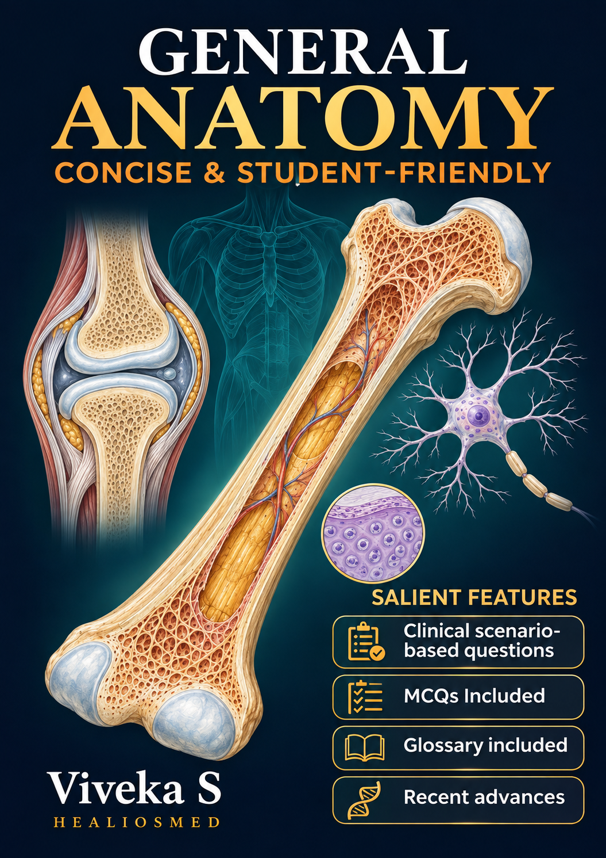

General Anatomy
Viveka S
Publication history
First edition: 2020
Kindle edition: October 2026
Published by: Healiosmed Education Private Ltd
Copyright
© 2026 Viveka S
Third-party illustrations and other reproduced material are credited in their respective captions or in the image credits.
Companion learning resources
anatomy.healiosmed.com
Educational purpose
This book is intended for anatomy education. Clinical examples illustrate anatomical principles and do not replace professional clinical assessment or guidance.
Corrections and feedback
Suggestions and corrections may be sent to healiosmed@gmail.com

Introduction
General anatomy provides the foundation for understanding the structure of the human body. Its terminology and principles recur throughout regional anatomy, histology, embryology, and clinical practice. A clear understanding of these fundamentals makes subsequent learning more manageable.
For a student entering medical school directly from higher secondary education, the first encounter with anatomy can be overwhelming. Comprehensive textbooks offer extensive detail, but the volume of unfamiliar terms and concepts can make it difficult to identify where to begin and what to understand first.
This book has been developed to make that beginning easier. It presents essential concepts in concise language, with emphasis on their meaning, relationships, and relevance. The aim is to establish a sound foundation that students can build upon as their studies progress.
The chapters introduce the basic principles of bones, cartilage, joints, fascia, skin, muscles, blood vessels, nerves, and lymphatics. Illustrations support the explanations, while clinical connections show why particular anatomical features matter. Questions encourage readers to explain concepts in their own words and apply them to unfamiliar situations.
Students are encouraged to read actively. After studying a topic, pause to recall its main ideas, identify the structures in the accompanying illustrations, and explain how structure relates to function. Returning to difficult concepts through questions and diagrams can help consolidate understanding.
Interactive learning resources: Companion activities covering the same topics are available at anatomy.healiosmed.com.
These include drag-and-drop exercises, fill-in-the-blank questions, multiple-choice questions, image hotspots, and interactive videos. They provide opportunities to identify structures, test recall, and apply the concepts introduced in the book.
For each topic, begin with the explanation and illustrations in the chapter, then use the corresponding online activities to assess your understanding. Revisit the relevant section when an answer reveals a gap in your knowledge.
The purpose is to help you approach anatomy with a clear starting point and the confidence to ask, explain, and connect.
Viveka S
MBBS, MD (Anatomy), DNB (Anatomy), Advance Course in Medical Education (2017)
Professor of Anatomy
Content Creator at Healiosmed.com

Contents
Anatomical Terminology 6
Basic Tissues 10
Epithelial tissue 10
Connective tissue 12
Muscle tissue 12
Nervous tissue 12
Skeletal system 17
Classification and naming of bones 17
Long bones 19
Blood supply of long bone 21
Endochondral Ossification 24
Intramembranous ossification 31
Epiphysis 33
Coracoid process of scapula 34
Law of ossification 36
Sesamoid bones and accessory bones 37
Accessory bones or supernumerary bones 39
Cartilage 42
Hyaline cartilage 42
Elastic cartilage 44
Fibrocartilage 44
Fascia and modifications of deep fascia 46
Modifications of Deep fascia 46
General Considerations of skin 48
Skin appendages 50
Skin incisions 52
Dermatoglyphics 54
Joints 57
Synovial joints 57
Cartilaginous joints 64
Symphysis 64
Vascular system 66
Vascular Anastomosis 68
Thrombosis 71
Muscles 75
Structural classification of muscles 76
Smooth muscle 76
Cardiac muscle 77
Skeletal muscle 77
Nervous system 85
Parts of brain 86
Lymphatic System 94
Structure of lymph capillaries 94
Review questions 98
Glossary 106

Anatomical Terminology
What is anatomy?
Anatomy is the study of the structure of the body.
The word anatomy comes from the Greek anatomē, meaning dissection or cutting up. It combines ana- (“up”) with a root from temnein (“to cut”). Dissection gave the subject its name.
Anatomy forms the basis of clinical practice
Anatomy helps clinicians locate a finding, identify the structures that may be involved, and explain the effect of an injury.
The same knowledge guides physical examination and procedures. A clinician uses a surface landmark to locate an underlying structure and considers what lies deeper before making an incision.
Anatomical position
In the anatomical position, the person stands upright with the head and eyes facing forward, the upper limbs at the sides, the palms facing forward, and the feet pointing forward. The thumbs lie lateral to the little fingers.
This position provides a common reference even when the person is lying down or moving. Right and left refer to the person being described.
- Supine means lying face up. It comes from Latin supinus, meaning “lying on the back.”
- Prone means lying face down. It comes from Latin pronus, meaning “inclined forward.”
Terms of relationship
A directional term usually compares one structure with another. For example, the second toe is lateral to the great toe, and the great toe is medial to the second toe.
Terms | Meaning | Word origin and example
Anterior / Posterior | Towards the front / back | Latin ante means “before” and post means “after” or “behind.” The sternum is anterior to the heart.
Superior / Inferior | Towards the head / feet | Latin superior means “higher” and inferior means “lower.” The heart is superior to the diaphragm.
Medial / Lateral | Towards / away from the median plane | Latin medius means “middle” and latus means “side.” The great toe is medial to the little toe.
Proximal / Distal | Nearer to / farther from the point of attachment or origin | Latin proximus means “nearest” and distare means “to stand apart.” The wrist is distal to the elbow.
Superficial / Deep | Nearer to / farther from the body surface | Superficial comes from Latin superficies, meaning “surface.” In a section of the arm, the humerus lies deep to the skin.
An inferior structure can carry fluid in a superior direction. The inferior vena cava lies below the heart and carries blood upwards towards the right atrium. Its name describes its position relative to the superior vena cava.
Planes and sections
A plane is an imaginary flat surface passing through the body. A section is the view obtained by cutting or imaging along a plane.
Plane | What it separates | Word origin
Median or midsagittal | Right and left halves at the midline | Latin medianus means “in the middle.”
Sagittal | Right and left portions. A sagittal plane away from the midline produces unequal portions. | Latin sagitta means “arrow.” The term is shared with the sagittal suture of the skull.
Coronal or frontal | Anterior and posterior portions | Latin corona means “crown.”
Transverse or axial | Superior and inferior portions | Latin transversus means “lying across.”
Oblique | Portions separated by a plane angled to the principal planes | Latin obliquus means “slanting.”

In the thoracic illustration from the deck, the yellow plane runs across the chest at the level of the sternal angle. It is a transverse plane
Named surfaces
The palmar surface is the palm side of the hand. The plantar surface is the sole of the foot. The opposite surface of each is its dorsum. These names come from Latin palma (“palm”), planta (“sole”), and dorsum (“back”).

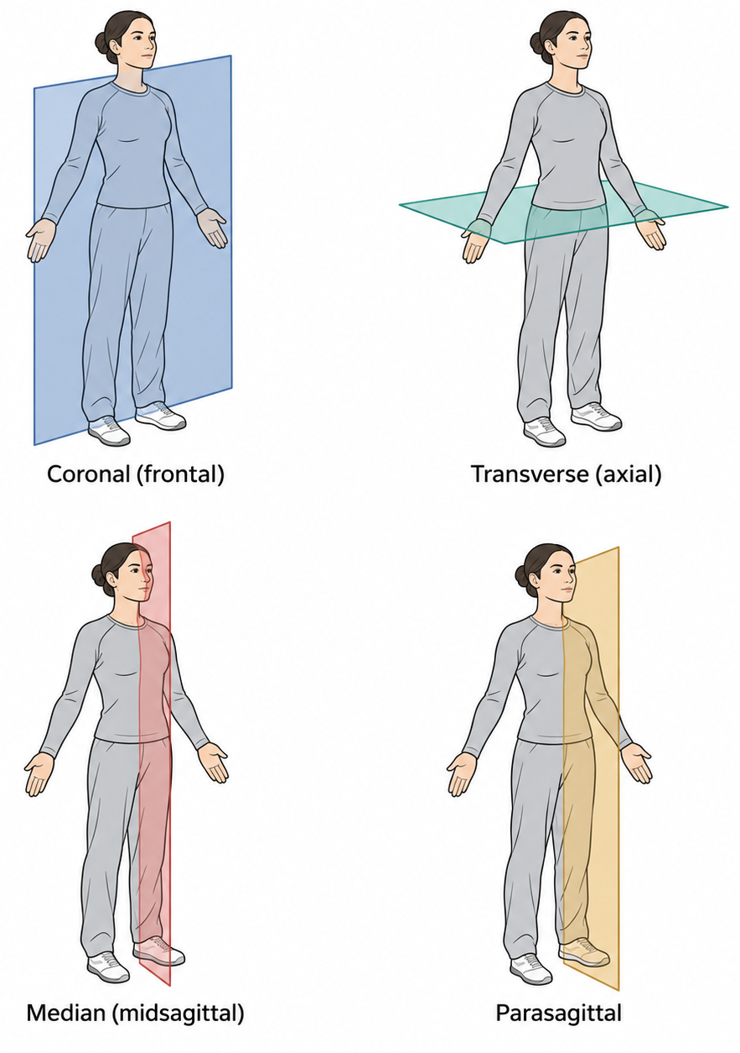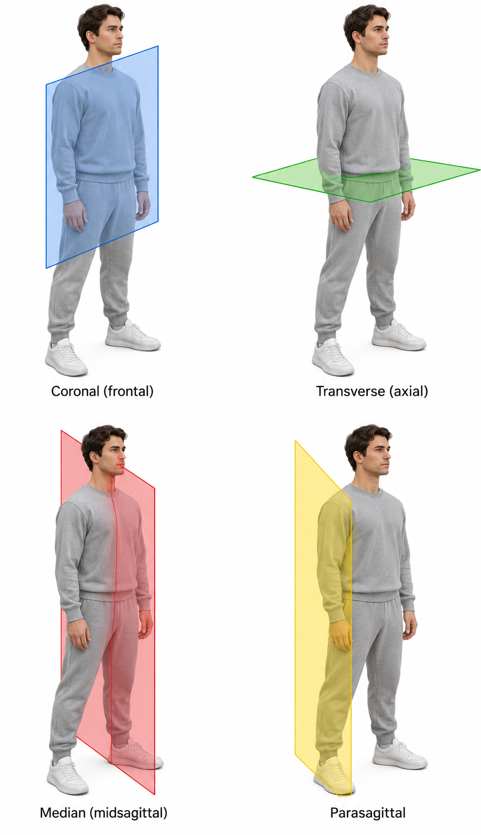
Figure: Planes of human body
Term s of movement
Movement | Meaning and example | Word origin
Flexion / Extension | Bending / straightening at a joint. Bending the elbow brings the forearm towards the arm. | Latin flectere means “to bend” and extendere means “to stretch out.”
Abduction / Adduction | Moving a limb away from / towards the median plane. Raising the arm sideways is abduction. Bringing it back to the side is adduction. | Latin abducere means “to lead away” and adducere means “to lead towards.”
Medial / Lateral rotation | Turning a limb about its long axis so its anterior surface turns towards / away from the midline. | Latin rota means “wheel.”
Circumduction | Moving the distal end of a limb in a circle by combining flexion, abduction, extension and adduction. | Latin circum means “around” and ducere means “to lead.”
Pronation / Supination | Rotating the forearm. With the elbow bent at a right angle and held at the side, pronation turns the palm down and supination turns it up. | From Latin pronus and supinus, the roots of prone and supine.

Digits have their own reference axes.
- The fingers abduct away from the middle finger and adduct towards it.
- The toes use the second toe as their reference.
- The thumb moves in a different orientation from the fingers. Moving it away from the plane of the palm is thumb abduction. Bringing its pad to meet a fingertip is opposition, from Latin opponere, meaning “to place against.”

Basic Tissues
A tissue is an organised group of cells and their surrounding material that work together to perform one or more functions. An organ combines several tissues. The small intestine, for example, uses epithelium to absorb nutrients, connective tissue to support its lining, smooth muscle to move its contents, and nervous tissue to coordinate that movement.
The body has four basic tissue types. The microscopic study of tissues is called histology, from the Greek histos, meaning “web” or “woven fabric,” and -logia, meaning “study.”
Tissue type | How to recognise it | Main function | Example
Epithelial | Closely packed covering cells arranged in a sheet | Covers surfaces, lines cavities, absorbs or secretes substances | Intestinal lining
Connective | Cells embedded in an extracellular matrix that varies with the tissue | Supports, binds, protects or transports | Tendon, cartilage, bone, blood
Muscle | Cells specialised to contract | Generates force and movement | Skeletal muscle, heart muscle, intestinal wall
Nervous | Neurons with processes, together with supporting glial cells | Receives, processes and transmits information | Brain, spinal cord, peripheral nerves

Epithelial tissue
Epithelium covers the body surface, lines internal spaces and passageways, and forms the secretory portions of many glands.
- Epithelial cells fit closely together, with little material between them.
- Epithelial cells show polarity. Their apical surface faces a free surface or a lumen, while their basal surface attaches to a thin supporting layer called the basement membrane. The Latin apex means “tip,” and basis means “base.”
- Epithelium is generally avascular, so nutrients reach its cells by diffusion, commonly from vessels in the underlying connective tissue.
Name an epithelium by its number of layers.
- Simple means one layer and stratified means several layers.
- In a stratified epithelium, the shape of the surface cells determines the name.
Classification of epithelium by cell shape
- Squamous cells are flat like scales, from Latin squama, meaning “scale.”
- Cuboidal cells are roughly cube-shaped
- Columnar cells are taller than they are wide.
Example | Structure and function
Simple squamous epithelium in lung alveoli | A thin layer of flat cells provides a short diffusion path for gases.
Simple cuboidal epithelium in many kidney tubules | A single layer of cube-shaped cells supports absorption and secretion.
Simple columnar epithelium in the small intestine | Tall cells form an absorptive lining. Microvilli increase its surface area.
Keratinised stratified squamous epithelium in the epidermis | Multiple layers and a keratinised surface protect against abrasion and limit water loss.
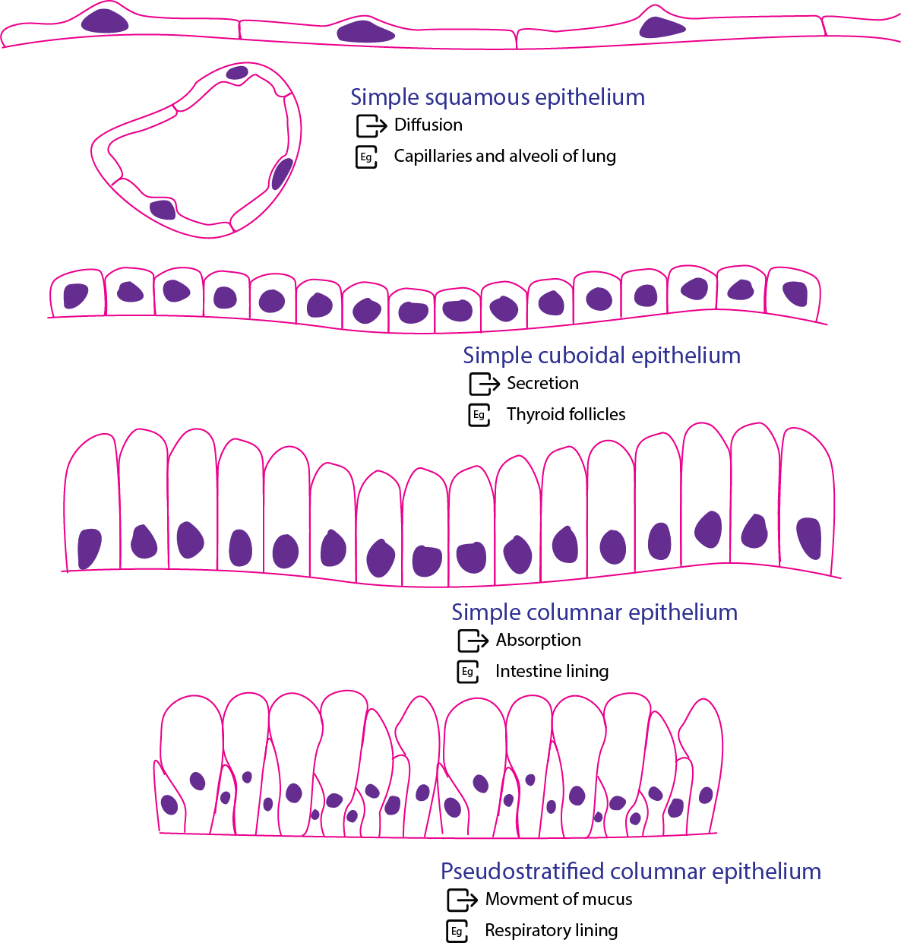
Figure: Simple squamous epithelium

Connective tissue
Connective tissue binds and supports other tissues. Its cells lie within an extracellular matrix, the material outside the cells.
In most connective tissues, this matrix contains fibres and ground substance, the material that fills the space around the cells and fibres.
Fibroblasts produce much of the matrix in connective tissue proper.
The composition and arrangement of the matrix explain why connective tissues behave differently:
- Loose connective tissue supports epithelia and surrounds small vessels and nerves.
- Dense connective tissue contains abundant collagen. In a tendon, the collagen bundles run mainly in the direction of pull, helping it resist tension.
- Cartilage and bone are supporting connective tissues. Cartilage has a firm, hydrated matrix that can resist compression. Bone has a mineralised matrix that provides rigidity.
- Adipose tissue stores energy and cushions structures. Blood is a fluid connective tissue whose cells are suspended in plasma.
Collagen fibres resist tension, while elastic fibres allow tissues to stretch and recoil.

Muscle tissue
Muscle tissue generates force by contraction.
- Skeletal muscle moves the skeleton and helps maintain posture.
- Cardiac muscle contracts to pump blood. Both are striated, meaning they show a banded appearance under the microscope.
- Smooth muscle lacks visible striations and is found in structures such as the intestinal wall and blood vessels.

Nervous tissue
Nervous tissue contains neurons and glial cells.
- Neurons receive, process and transmit signals.
- Glial cells help maintain the environment in which neurons work. The word glia comes from the Greek word for “glue.”
- Some form myelin, which helps signals travel rapidly along axons.
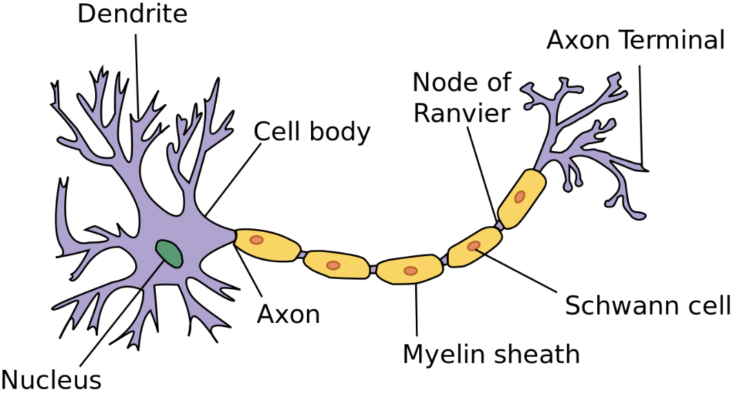
Figure: multipolar neuron
Key points to remember
- Epithelium forms a cellular boundary.
- Connective tissue derives much of its mechanical behaviour from its matrix.
- Muscle generates force, and nervous tissue transmits impulses.
- Healing can restore different layers in different ways. A surface may regain its epithelium while the deeper tissue heals by scarring.
Why tissues heal differently
- Regeneration replaces damaged cells with cells of the same type.
- When injury destroys the framework needed for regeneration or the cells have limited capacity to divide, repair by fibrosis can fill the defect with collagen-rich scar tissue.
- Both processes can occur in the same wound.
Many surface epithelia renew readily when viable cells and their supporting framework remain.
- A deeper skin wound can regain an epithelial covering while leaving a scar in the dermis.
Articular cartilage has limited repair capacity, and substantial loss of cardiac muscle typically heals by scar formation

Key Diagnostic IHC & Cellular Markers for Primary Human Tissue Types
In surgical pathology and histology, differentiating undifferentiated tumors or identifying embryological origins relies on tracking lineage-specific proteins, structural filaments, and receptor classes using Immunohistochemistry (IHC).
Primary Tissue Type | Specialized Subtype | Key Cellular / Molecular Markers | Clinical & Diagnostic Signification
EPITHELIAL TISSUE | General Epithelium | Pan-Cytokeratin (pan-CK) (e.g., AE1/AE3),  E-cadherin,  Epithelial Membrane Antigen (EMA) | Confirms epithelial origin; essential to diagnose Carcinomas (cancers of epithelial cells).
 | Glandular / Simple | Cytokeratin 7 (CK7),  CK20,  E-cadherin,  CAM5.2 | Key "CK7/CK20" panel used to determine the primary site of metastatic adenocarcinomas (e.g., CK7−/CK20+ is highly specific for colorectal origin).
 | Squamous / Basal | Cytokeratin 5/6 (CK5/6),  p63,  p40,  High-Molecular-Weight Cytokeratin (34βE12) | Confirms squamous cell differentiation (e.g., lung or cervical squamous cell carcinoma).  p40 is more specific than p63 for squamous lineage.
 | Mesothelial Lineage | Calretinin,  Wilms Tumor 1 (WT1),  D2-40 (Podoplanin),  Cytokeratin 5/6 | Distinguishes Mesothelioma (cancer of the pleural/peritoneal lining) from metastatic adenocarcinoma.
CONNECTIVE TISSUE (Mesenchymal) | General Mesenchyme | Vimentin  (universal mesenchymal intermediate filament) | Confirms mesenchymal/connective tissue origin.  Expressed in Sarcomas (cancers of connective tissue) and cells undergoing EMT.
 | Fibrous / Fibroblastic | Vimentin,  CD34 (in some stromal networks),  Fibronectin | Marks fibroblasts, fibrocytes, and related spindle-cell tumors.
 | Adipose (Fat) | S100 (diffuse),  MDM2 (amplified in liposarcomas),  Perilipin,  Calretinin (weak) | Identifies adipocytes;  MDM2 amplification differentiates atypical lipomatous tumors/liposarcomas from benign lipomas.
 | Cartilage & Bone | S100 (chondrocytes),  SOX9 (master chondrocyte transcription factor),  SATB2 (osteoblasts),  Osteocalcin | SATB2 is a highly sensitive and specific nuclear marker for osteogenic differentiation (confirms osteosarcoma).
 | Endothelial (Vessels) | CD31 (PECAM-1),  CD34,  ERG (ETS-related gene, nuclear),  Factor VIII-Related Antigen (vWF) | Confirms vascular or lymphatic origin. Essential to diagnose Angiosarcomas and Kaposi's sarcoma.  ERG is highly specific.
 | Lymphatic Endothelium | D2-40 (Podoplanin),  PROX1 | Distinguishes lymphatic channels from blood vessels (useful in tracking lymphatic invasion by tumors).
 | Melanocytic | S100 (highly sensitive),  SOX10 (extremely lineage-specific),  Melan-A (MART-1), HMB45 | Identifies melanocytes and diagnoses Melanoma.  SOX10 and S100 are nuclear/cytoplasmic markers used to map obscure metastases.
 | Hematopoietic & Immune | CD45 (LCA - Leukocyte Common Antigen),  CD3 (T-cells),  CD20 (B-cells),  CD68 & CD163 (histiocytes/macrophages) | CD45 positivity confirms a hematolymphoid origin (e.g., Lymphoma/Leukemia) over carcinoma or sarcoma. CD3/CD20 are standard classification markers.
MUSCLE TISSUE | General Muscle | Desmin (muscle-specific intermediate filament) | Confirms myogenic lineage.  Positivity establishes smooth, skeletal, or cardiac differentiation.
 | Skeletal Muscle | Myogenin,  MyoD1 (both nuclear master regulators),  Desmin,  Myoglobin,  Fast/Slow Skeletal Troponins | Nuclear Myogenin/MyoD1 is the gold-standard diagnostic marker for Rhabdomyosarcoma (pediatric small round blue cell tumor).
 | Smooth Muscle | Smooth Muscle Actin (SMA), Calponin,  h-Caldesmon,  Smooth Muscle Myosin Heavy Chain (SMMHC) | Diagnoses smooth muscle tumors (leiomyomas and leiomyosarcomas).  h-Caldesmon and SMMHC are the most specific for true smooth muscle.
 | Cardiac Muscle | Cardiac Troponin I (cTnI),  Cardiac Troponin T (cTnT),  Nkx2-5 (nuclear),  GATA4 | Specific to myocardium;  cTnI/cTnT are released into blood during myocardial infarction (used as serum biomarkers).  Nkx2-5 is a lineage master.
NERVOUS TISSUE | Central (Neurons) | Synaptophysin (synaptic vesicles),  Chromogranin A (neurosecretory),  NSE (Neuron-Specific Enolase),  NeuN (mature nuclei),  Neurofilament (NF) | Positivity confirms neuroendocrine or neuronal lineage.  NeuN is highly specific for mature post-mitotic neurons.
 | Glial Cells (Astrocytes) | GFAP (Glial Fibrillary Acidic Protein) | Confirms glial origin; the hallmark marker to diagnose Astrocytomas and Glioblastomas.
 | Schwann Cells (PNS) | S100, SOX10 | Essential for PNS myelinating cells. Diagnostic for Schwannomas and Neurofibromas.

Epithelial-Mesenchymal Transition (EMT) and tissue plasticity
Anatomy has traditionally viewed epithelial and connective (mesenchymal) tissues as distinct, fixed categories. However, modern cellular anatomy recognizes phenotypic plasticity through the process of Epithelial-Mesenchymal Transition (EMT).
During EMT, cohesive, polarized epithelial cells dismantle their intercellular junctions, lose their connection to the basement membrane, reorganize their cytoskeleton, and migrate as solitary, spindle-shaped mesenchymal cells.
The Three Types of EMT in Anatomy and Medicine:
- Type 1 (Developmental):
  - Essential for embryogenesis and morphogenesis.
  - Without Type 1 EMT, the early embryo could not form the three germ layers (ectoderm, mesoderm, and endoderm) during gastrulation.
  - It is also responsible for the migration of neural crest cells and the formation of the heart valves.
- Type 2 (Regenerative and Fibrotic):
  - Involved in tissue repair and organ remodeling.
  - Following injury, epithelial cells at the wound edge can undergo EMT to become mobile, migrating into the wound to generate the extracellular matrix needed for healing.
  - If this process becomes chronic, it results in organ fibrosis (e.g., in the kidneys or liver).
- Type 3 (Oncogenic / Pathological):
  - Occurs when neoplastic epithelial cells (carcinomas) hijack this developmental program to gain the invasive and migratory traits necessary to intravasate into blood vessels, resulting in metastasis to distant organs.

Skeletal system
Key points to remember:
- Bone shape reflects function
- Long bones act as levers, flat bones provide protection and attachment surfaces, and short bones contribute to stability.
- Intramembranous ossification forms bone directly within mesenchyme
- Endochondral ossification replaces a cartilage model.
- Growth plates increase bone length, while appositional deposition increases thickness; longitudinal growth at a plate ends when it closes.
- Blood supply is essential for bone survival and repair

Classification and naming of bones
Classification based on shape
Based on shape bones can be classified into
- Long bones
  - Lengthier bones
  - Eg. Femur, humerus, phalanges
- Short bones
  - Small and stout bones
  - Eg. Carpal bones
- Irregular bones
  - Shape is irregular
  - Eg. Vertebrae
- Flat bones
  - These bones are flat
  - Eg. Scapula
- Pneumatic bones
  - Bones with air filled cavities
  - Eg. Maxilla, frontal bone, sphenoid, mastoid part of temporal bone
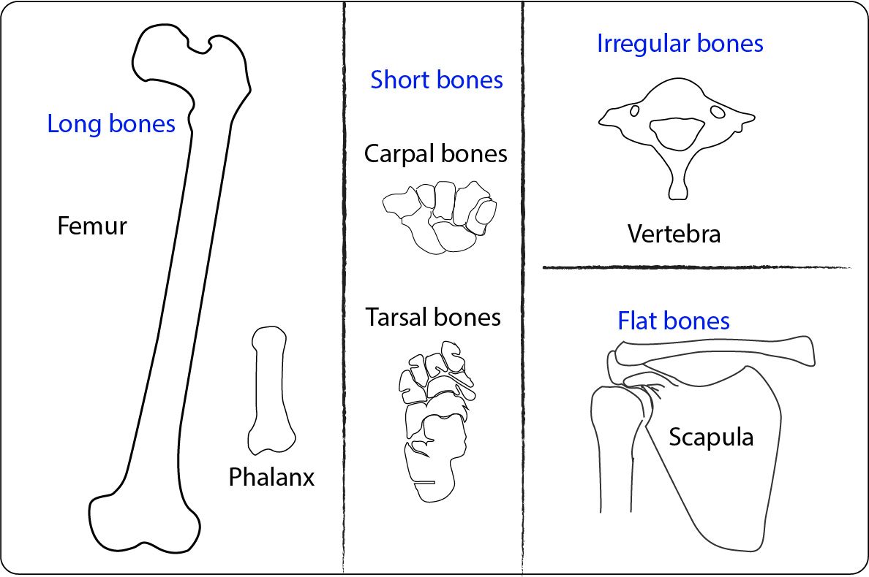
Figure 1: Classification based on shape

Classification based on the microscopic structure
Bones are classified on the basis of macroscopic structure into
Compact bone
- Also called as cortical bone
- Has dense microscopic lamellae
Cancellous bone
- Also called as spongy bone
- Has many irregular spaces in between

Classification of bones based on position
Bones are classified as
Axial bones
- Bones forming the axis of the body
- Eg. Vertebrae, ribs, skull
Appendicular bones
- Bones of limbs
- Eg. Humerus, radius, ulna; Femur, tibia, fibula

Long bones
Characteristics of Long bone
  - Length > breadth
  - Shaft & 2 ends
  - Tubular in shape
  - Weight bearing
  - Endochondral ossification
  - One primary & two secondary ossification centres (usually)

Characteristics of young bone
- Endochondral framework
- Epiphyseal growth plate present

Ossification centers
- Long bones have one primary center forming the diaphysis
- Multiple secondary centers forms parts of epiphysis

Types of long bones
Typical long bones
- Eg: Femur, tibia, humerus, radius and ulna
Miniature long bones
- Eg: Phalanges, metacarpals, metatarsals
Modified long bones
- Eg: Clavicle - No medullary cavity
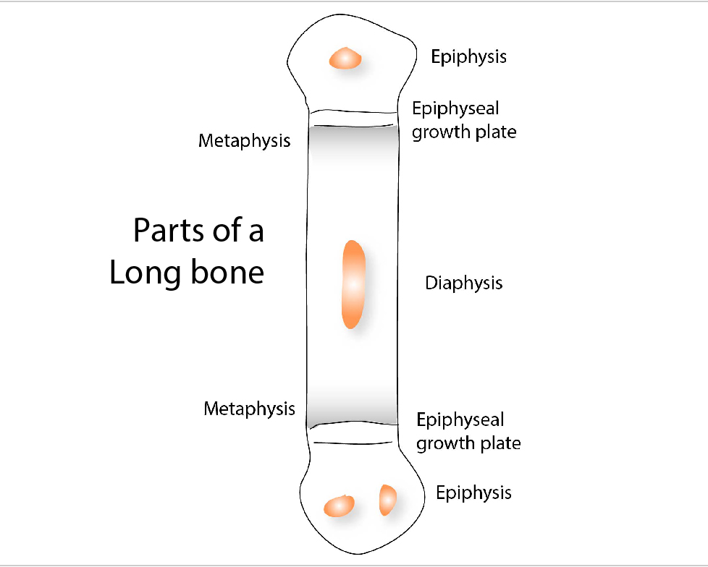

Parts of long bones
- Diaphysis
- Epiphysis
- Metaphysis
- Epiphyseal plate of cartilage

Diaphysis
- It is the elongated shaft (middle portion) of the bone
- Ossifies from primary center
Epiphysis
The ends of the bone that ossifies from secondary centers
Four types
- Pressure epiphysis
- Traction epiphysis
- Aberrant epiphysis
- Atavistic epiphysis
Metaphysis
- Zones of active bone growth at the ends of the diaphysis
- Metaphysis has rich blood supply
- Common site of osteomyelitis (Inflammation of the bone) in children
- As the arteries make a sharp bend at metaphysis - bacteria or thrombus can easily get trapped in the region - making it more susceptible to inflammation.
Epiphyseal plate of cartilage
- Separates epiphysis and metaphysis
- Proliferation of cells in this region - lengthens the bone
- Growth plate is nourished by both epiphyseal and metaphyseal arteries

Blood supply of long bone
Bone is richly vascular and is supplied by
- Nutrient artery
- Periosteal arteries
- Metaphyseal arteries
- Epiphyseal arteries
Nutrient artery
Passes through the cortical bone in shaft
Runs obliquely in the foramen
Foramen is called – nutrient foramen
Directed away from the growing end

Mnemonic to remember the direction
Towards the elbow I go, away from the knee I flee

No branches in the foramen
Divides into ascending and descending branches
Each branch divides into smaller helical branches - Centripetal branching
Periosteal arteries
- Numerous
- Enter through Volkmann’s canal
- Supply outer third of the cortex
- Enter through enthesis – place of attachment of tendon to bone.
Metaphyseal arteries
- Enter metaphysis directly
Epiphyseal arteries
- Derived from anastomotic circle around the joint – circulus vasculosus

Area of supply
Epiphyseal and metaphyseal arteries supply more area than diaphyseal arteries
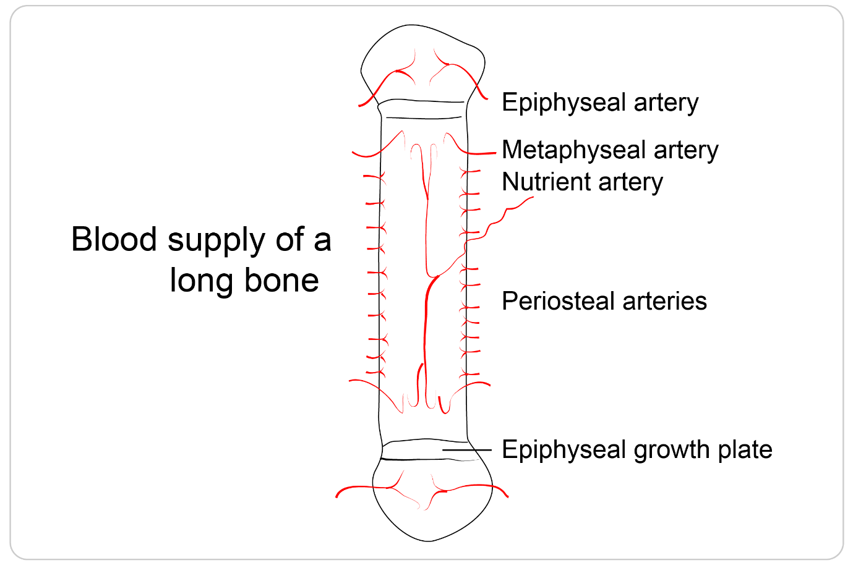
Clinical importance - Epiphyseal growth plate fractures
- Salter - Harris fracture - fracture involving epiphyseal growth plate, particularly zone of provisional calcification
- Type 2 is more common fracture subtype, where the fracture line passes through the growth plate and metaphysis, spares the epiphysis.

Clinical importance - Osteomyelitis
- Metaphysis has rich blood supply
- Metaphysis - Common site of haematogenous osteomyelitis (Inflammation of the bone) in children
- As the arteries make a sharp bend at metaphysis - bacteria or thrombus can easily get trapped in the region - making it more susceptible to inflammation.

Clinical importance - Avascular necrosis
Lack of blood supply to the epiphysis leads to avascular necrosis (AVN)
Head of femur is the most commonly affected bone
Few named (eponymous) avascular necrosis -
- Legg-Calve-Perthes disease - femoral head
- Preiser disease - scaphoid
- Kienbock disease - lunate
- Dias disease - trochlea of the talus
Clinical importance - Osgood-Schlatter disease
- Stress on the epiphyseal growth plate of the upper end of tibia leads to excess bone growth

Endochondral Ossification
How does a cartilage model become a growing bone?
A child’s long bones must provide support while continuing to grow. This is possible because bone formation and cartilage growth occur together in an organised sequence. Cartilage establishes the early framework and provides a continuing growth mechanism; bone progressively replaces it.
Definition: Endochondral ossification is the formation of bone through the progressive replacement of a pre-existing cartilage model. It contributes to the development of most bones of the skeleton, including the long bones of the limbs.
The cartilage matrix becomes calcified during the process, but calcified cartilage and bone are different tissues. Osteoblasts deposit new bone matrix on a temporary framework of calcified cartilage.
The cartilage model
- Development begins when mesenchymal cells collect at the site of the future bone.
- These cells differentiate into cartilage-forming cells and produce a model of hyaline cartilage.
- The model resembles the general shape of the future bone.
- The cartilage is surrounded by
- perichondrium, a connective tissue covering containing cells capable of further differentiation.
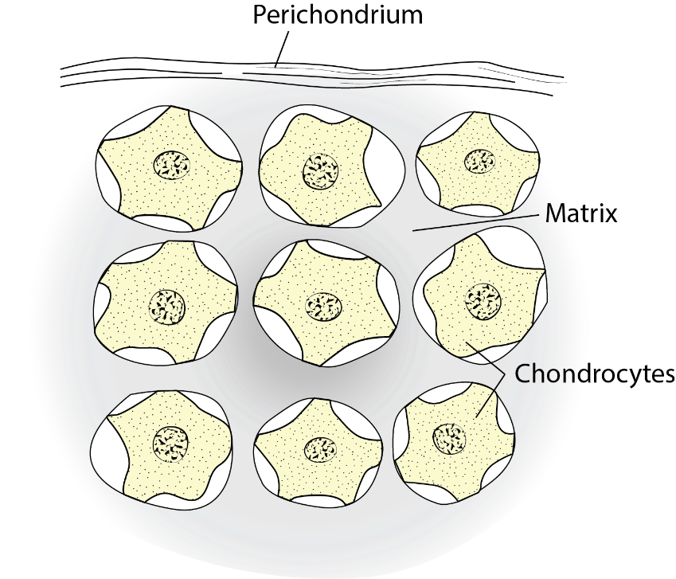
Figure : The early cartilage model
At this stage, the model grows through cartilage formation. Chondrocytes divide within the matrix, while cells at the surface contribute additional cartilage.
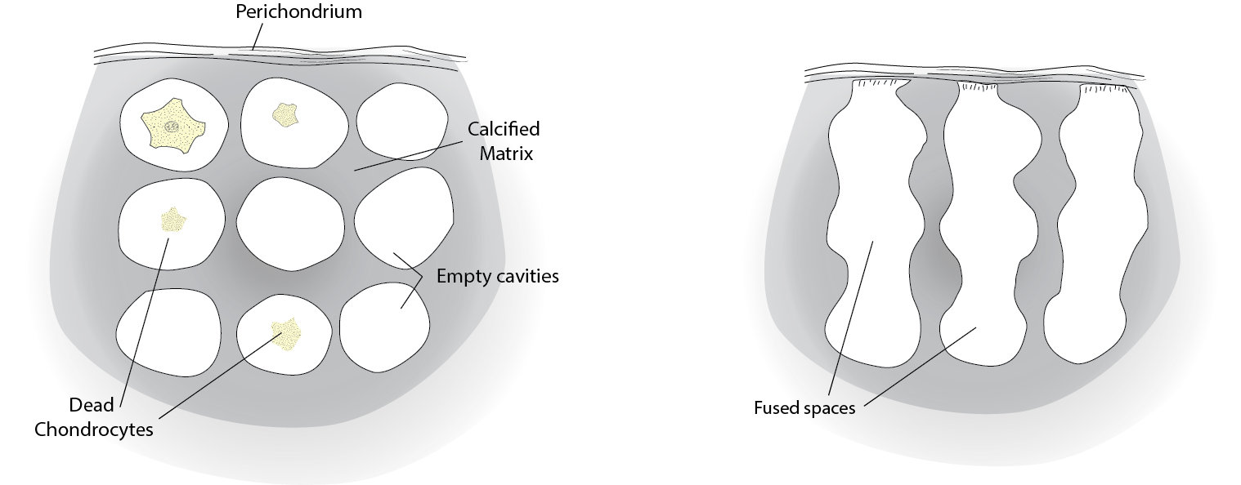
Figure : Changes in the cartilage model
Changes in the centre of the model
The earliest major changes occur around the future shaft, or diaphysis.
Chondrocyte hypertrophy → matrix calcification → loss of many chondrocytes → invasion and replacement by bone.
Formation of the bone collar
While changes occur inside the cartilage model, cells in the surrounding perichondrium differentiate into osteoblasts.
These osteoblasts deposit osteoid, the unmineralised organic matrix of bone. Mineralisation of this matrix produces a thin bone collar around the shaft.
The collar forms directly within connective tissue, without an intervening cartilage stage. Its formation is therefore an example of intramembranous ossification occurring during the development of a bone that otherwise develops predominantly through endochondral ossification.
The connective tissue covering now acquires the characteristics of periosteum.
The distinction matters:
- Bone collar: the newly formed layer of bone.
- Periosteum: the connective tissue covering outside that bone.

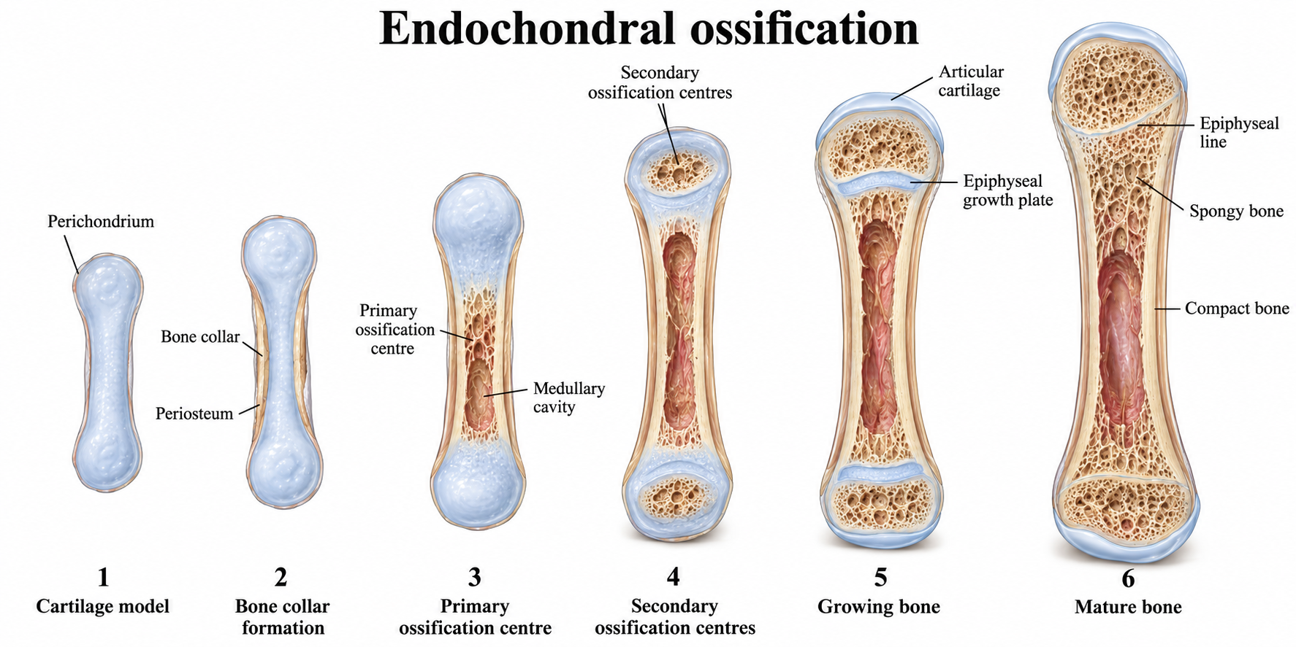
Figure: Bone collar and central cartilage changes
Vascular invasion and the primary ossification centre
Blood vessels penetrate the developing collar and enter the altered cartilage.
The invading vascular tissue is traditionally described as the periosteal bud or osteogenic bud. It brings blood vessels, osteoprogenitor cells, and cells involved in the developing marrow and tissue-resorption processes.
Osteoprogenitor cells differentiate into osteoblasts. Mature osteocytes are not transported into the model to begin bone formation; osteocytes develop when osteoblasts become enclosed within the matrix they produce.
The region in the diaphysis where bone formation begins is the primary ossification centre.
Osteoblasts deposit osteoid on surviving spicules of calcified cartilage. The early trabeculae therefore contain a cartilage core covered by newly deposited bone.
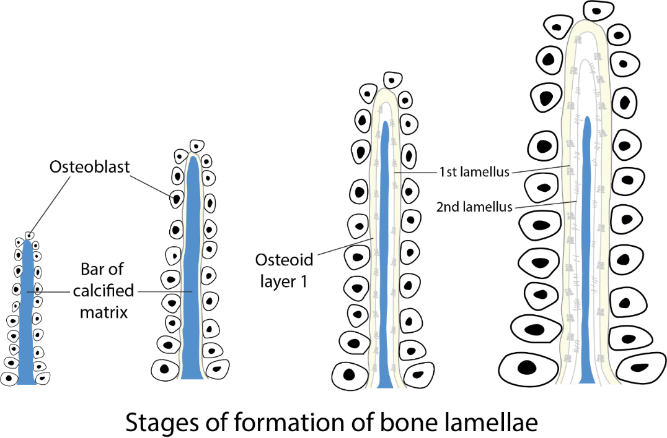
Figure: Osteoblasts deposit bone on remnants of calcified cartilage following vascular invasion
Formation of the medullary cavity
Resorptive cells remove portions of the calcified cartilage and newly formed trabeculae. Spaces enlarge and join, contributing to the development of the medullary cavity.
The initial bone is remodelled into more organised lamellar bone. Remodelling requires both resorption by osteoclasts and formation by osteoblasts; it cannot be attributed to osteoclasts alone.
Ossification extends from the central shaft towards both ends of the developing bone.
Secondary ossification centres
The ends of the developing long bone are the epiphyses.
Secondary ossification centres appear within these cartilaginous ends. Their timing varies between bones: many appear after birth, while some are present before birth.
Vascular invasion and bone deposition occur within the epiphyseal cartilage. The developing epiphysis retains predominantly trabecular architecture rather than acquiring a shaft-like medullary cavity.
Two important regions of cartilage remain:
- Articular cartilage, covering the joint surface.
- Epiphyseal growth plate, between the epiphysis and metaphysis.
The articular cartilage provides a specialised joint surface. The growth plate supports continued longitudinal growth.
How the growth plate increases bone length?
The epiphyseal plate, also called the physis or growth plate, is a specialised region of cartilage between the epiphysis and metaphysis.
Length increases because cartilage is continually produced and enlarged within the plate and then replaced by bone on its metaphyseal side.
This process moves the epiphysis progressively away from the shaft.
The plate is a dynamic structure. Its continued presence depends on the relationship between cartilage production and cartilage replacement.
From the epiphysis towards the metaphysis, the changes can be understood in five regions.
Region | Main appearance or event | Significance
Resting cartilage | Small chondrocytes within relatively abundant matrix | Provides a reserve population and supports plate organisation
Proliferation | Dividing chondrocytes arranged in longitudinal columns | Produces additional cartilage
Hypertrophy | Chondrocytes and their lacunae enlarge | Contributes substantially to longitudinal growth
Provisional calcification | Thin cartilage septa become mineralised | Creates the temporary framework at the replacement front
Ossification | Vessels invade and osteoblasts deposit bone on cartilage remnants | Adds new bone on the metaphyseal side

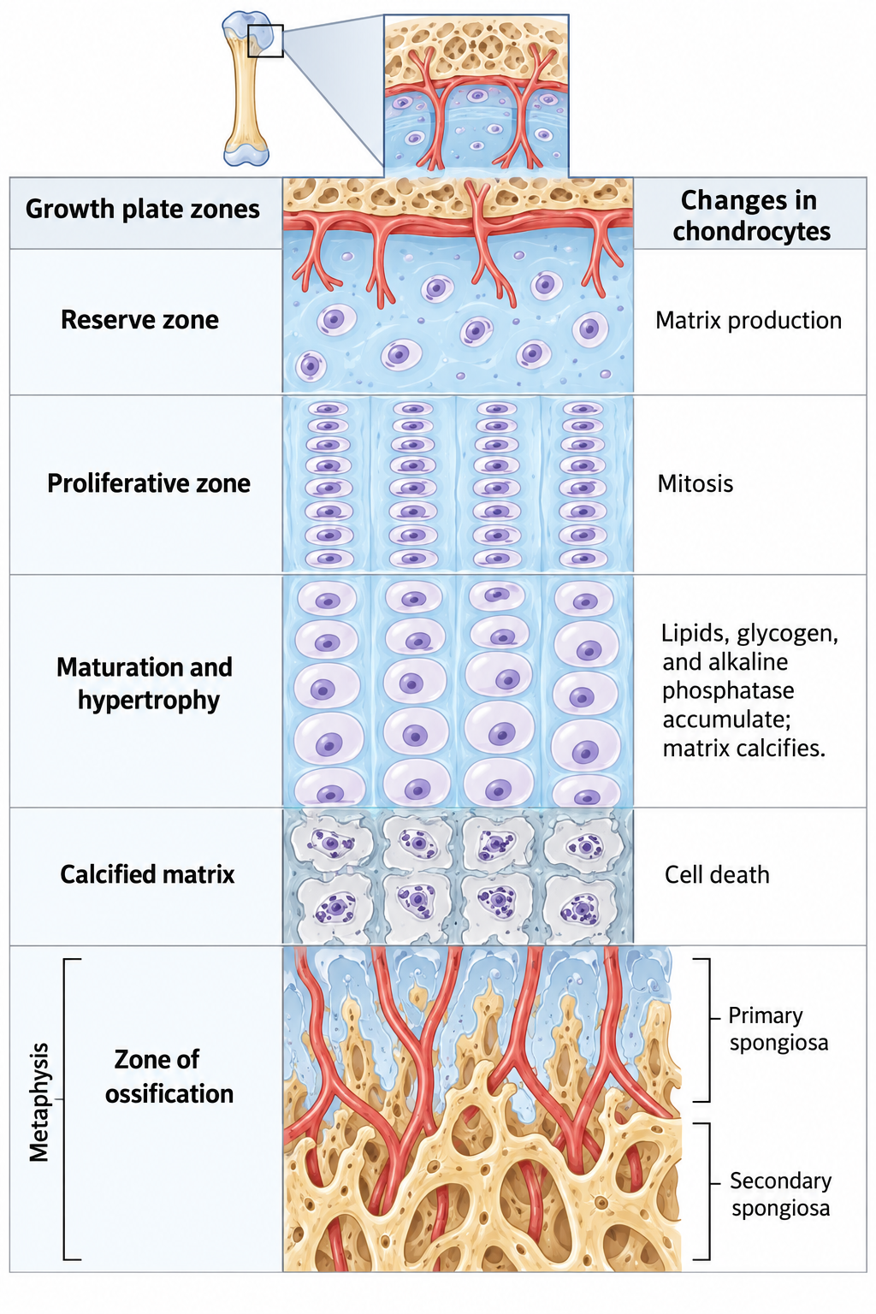
Figure: Growth plate diagram - The growth plate displays a spatial sequence of cartilage production, enlargement, calcification, and replacement by bone
Ref: Ağırdil Y. The growth plate: a physiologic overview. EFORT Open Rev. 2020 Sep 10;5(8):498-507. doi: 10.1302/2058-5241.5.190088. PMID: 32953135; PMCID: PMC7484711.
Growth-plate closure
Towards skeletal maturity, growth-plate activity declines. Eventually, the remaining cartilage is replaced by bone, establishing continuity between epiphysis and metaphysis.
This is epiphyseal fusion or growth-plate closure. An epiphyseal line may remain visible.
After closure, that growth plate can no longer contribute to longitudinal growth. The bone remains living tissue and continues to remodel.
The timing of closure varies with the particular bone, hormonal influences, and individual development. A single age should not be applied to all growth plates.
Length and thickness increase by different mechanisms
Longitudinal growth depends on the growth plate.
Growth in thickness occurs through appositional bone deposition, particularly at the periosteal surface. Associated resorption and formation reshape the bone and its internal cavity.
Consequently, endochondral development includes several coordinated processes:
- Cartilage growth.
- Replacement of cartilage by bone.
- Direct bone deposition at surfaces.
- Resorption and architectural reorganisation.
- Clinical connections
Growth-plate injury
An injury crossing the growth plate may disturb its organisation or lead to a bridge of bone across part of the plate.
If growth stops across the whole plate, the affected bone may become relatively short. If growth stops on one side while continuing on the other, angular deformity may develop.
Vitamin C is required for normal collagen formation. Severe deficiency causes scurvy and impairs connective tissue integrity
Infection in growing bones - blood-borne osteomyelitis commonly involves the metaphysis
The growth plate itself is avascular cartilage.
The vascular arrangement favours bacterial localisation. Infection can damage adjacent growth structures. Vascular relationships also change with age.

- Do all hypertrophic chondrocytes disappear?
The traditional account describes hypertrophic chondrocytes dying before bone replaces the cartilage. It does not mean that the entire cartilage matrix becomes bone without replacement.
Ref: Yang L, Tsang KY, Tang HC, Chan D, Cheah KS. Hypertrophic chondrocytes can become osteoblasts and osteocytes in endochondral bone formation. Proc Natl Acad Sci U S A. 2014 Aug 19;111(33):12097-102. doi: 10.1073/pnas.1302703111. Epub 2014 Aug 4. PMID: 25092332; PMCID: PMC4143064.
Key points to remember
- Endochondral ossification uses a cartilage model.
- Calcified cartilage provides a temporary scaffold for new bone.
- The bone collar forms by intramembranous ossification.
- The periosteum and bone collar are separate structures.
- Primary ossification begins in the shaft; secondary centres develop in the epiphyses.
- The growth plate permits longitudinal growth until closure.
- Bone growth and remodelling require coordinated formation and resorption.

Intramembranous ossification
Definition: Intramembranous ossification is the direct formation of bone within ‘membranes’ of condensed primitive mesenchyme
Salient features:
Mesenchymal precursor cells differentiate directly into bone-forming osteoblasts

- Bone is formed within highly vascular membranes
- Bones of cranial vault form by this process
- Gaps in membranous bones of cranial vault allow moulding. Moulding is adaptation of fetal head to pressure in birth canal.
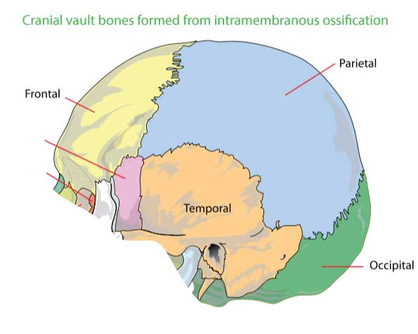
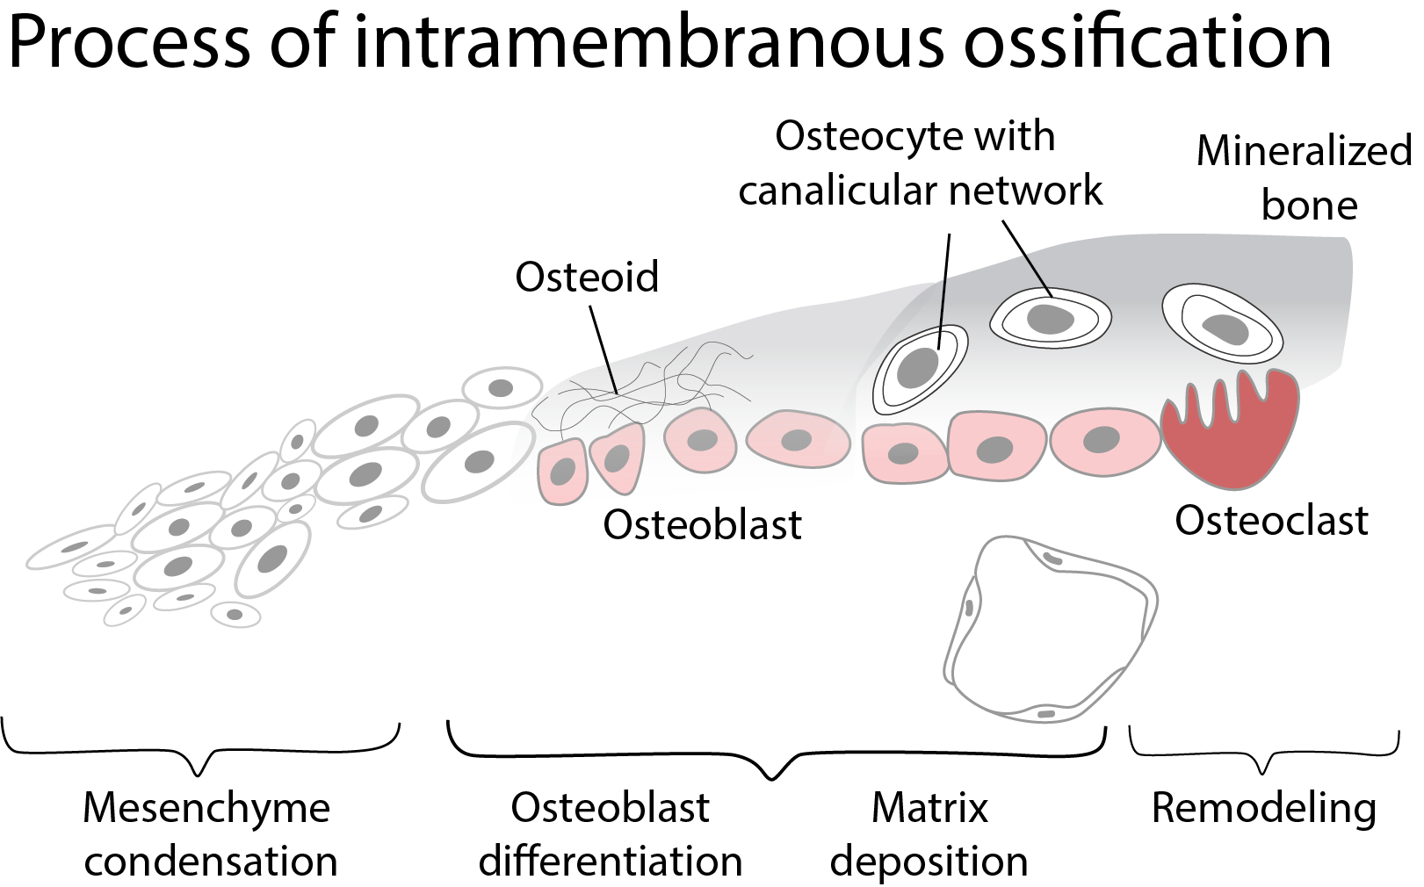
Process of intramembranous ossification
- During embryonic development – mesenchymal cells condense as a membrane
- At the centres of ossification, mesenchymal stem cells differentiate into osteoprogenitor cells
- These cells proliferate around blood capillaries
- Osteoprogenitor cells differentiate to osteocytes and later osteoblasts
- This results in osteoblasts arranged in incomplete layers
- Primitive bone matrix forms around these cells
- Earliest ossification in the form of crystals appear in association with extracellular matrix vesicles
- This produces early labyrinthine woven bone
- Many layers of calcifying matrix will be added to this structure
- Such layers with osteoblasts forms trabeculae of varying thickness
- Mesenchyme on the outer aspect condense and form periosteum
- Collagen fibres of the matrix, secreted on the walls of the narrowing spaces between trabeculae, become organized as parallel, longitudinal or spiral bundles, and the cells they enclose occupy concentric sequential rows
- This structure have a central canal, and are called primary osteons
- Later they are eroded and together with intervening woven bone, and replaced by generations of secondary osteons
- Modelling of the growing bone is achieved by varying rates of resorption and deposition at different sites
Periostin is the marker of intramembranous ossification
Bones formed through intramembranous ossification
- Bones that constitute cranial vault
  - Frontal bone
  - Occipital bone
  - Parietal bone
- Bones of viscerocranium
  - Mandible
  - Maxillary bone
  - Zygomatic bone
  - Squamous part of temporal bone
- Clavicle
- Deposition of bone on outer surface of long bones

Applied aspects
- Fracture healing
Histologic characterization of fracture healing shows that intramembranous ossification occurs under the periosteum within a few days after an injury.
- Craniosynostosis
Abnormal closure of sutures between membranous bones of cranial vault results in craniosynostosis.

Epiphysis
Definition: Ends of the long bone formed from separate ossification centers are epiphysis
Cartilaginous extremity at the epiphysis ossify after birth forming secondary center
Features
- Usually - long bones have one or multiple epiphyseal centers at each end
- Short long bones have one epiphysis (eg: phalanges, metacarpals have one epiphysis)
- Articular surfaces of epiphysis are covered with hyaline articular cartilage
Types of epiphyses
- Pressure epiphysis
- Traction epiphysis
- Atavistic epiphysis
- Aberrant epiphysis

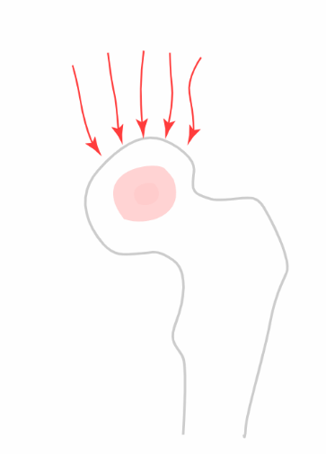
Pressure epiphysis
- Transmits body weight
- Formed at the articulating ends of the long bones
Eg: head of femur, upper end of humerus.
Traction epiphysis
- Formed by pull of muscles or tendon
Eg: trochanters of femur, tubercles of humerus
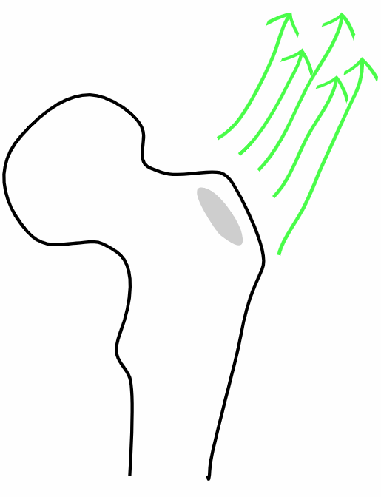
Atavistic epiphysis
- Independent bones of the lower animals are fused to nearby bones in mammals
- Grows like parasite
Eg: Coracoid process of scapula, os trigonum of talus
Etymology: relating to or characterized by reversion to something ancient or ancestral

Coracoid process of scapula
- Atavistic epiphysis
- Hook shaped projection from the upper aspect of scapula
- Separate bone of shoulder girdle in birds and other lower animals
- Etymology: coracoid - like raven's beak
Attachments
Muscles
- To the tip - combined attachment of short of biceps brachii and coracobrachialis
- To medial aspect - pectoralis minor
Ligaments
- Coracoclavicular, coracohumeral, coracoacromial, and transverse scapular ligaments
Clinical importance
- Coracoid process - considered as lighthouse of shoulder
- Because it is very close to major neurovascular structures - including brachial plexus, axillary artery and vein
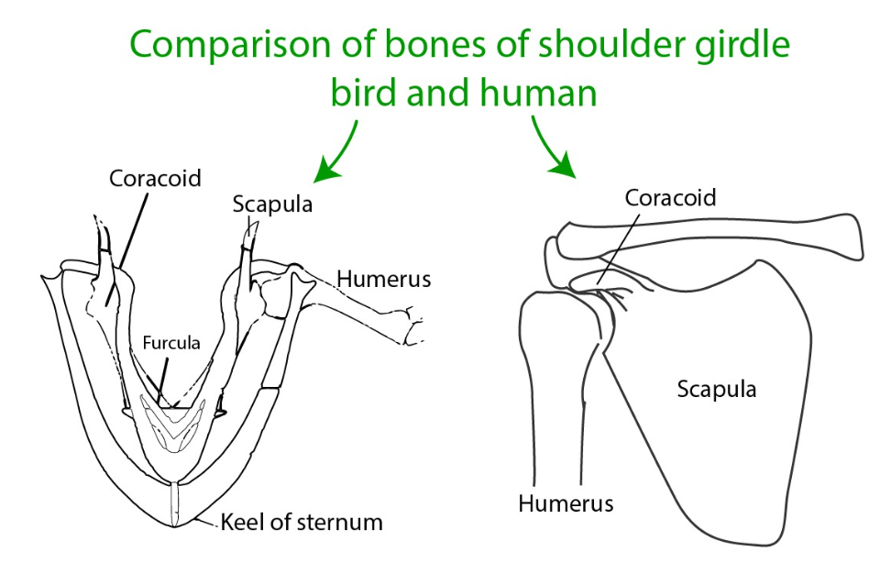
Aberrant epiphysis
- Deviations from the normal
- Not always present
Eg: epiphysis at the head of first metacarpal & at the base of other metacarpal bones
Clinical importance
- Avascular necrosis
  - Lack of blood supply to the epiphysis leads to avascular necrosis (AVN)
  - Head of femur is the most commonly affected bone
- Osteochondritis dissecans
  - Deprivation of blood supply in the subchondral bone leads to osteochondritis dissecans
  - Loose fragments of cartilage and bone are found within a joint
- Slipped Capital Femoral Epiphysis (SCFE)
  - A condition where the femoral metaphysis slips relative to the epiphysis leading to varus relation between the head and the neck

Law of ossification
In the simplest form - the law can be stated as
The centres that appear first, fuse last
More specifically -
The epiphysis that appears first will fuse with the diaphysis last
Clearly the law can be stated as -
The secondary centers appearing first fuses with the primary center last
All three sentences mean the same

Exception
Lower end of fibula - secondary center appears first and fuses first
Fibula
- Epiphysis of the upper end of fibula (traction epiphysis) appears by 3-4 years and fuses with the shaft by 17-19 years
- Epiphysis of the lower end of fibula appears by 1 year and fuses with the shaft by 15-17 years
Reason
Proximal epiphysis of fibula (traction epiphysis) do not form until 2 years
Possible explanations are
- As the proximal end of fibula is bound to growing end of tibia, delay in appearance of proximal end may be explained.
- Early walking by infant may influence the formation of distal epiphysis earlier
- Early distal ossification may be a continuation process of rapid perinatal growth of lower end
Or pattern of ossification of the human fibula is a widespread mammalian characteristic. This may not be related to any special features of the human skeleton.
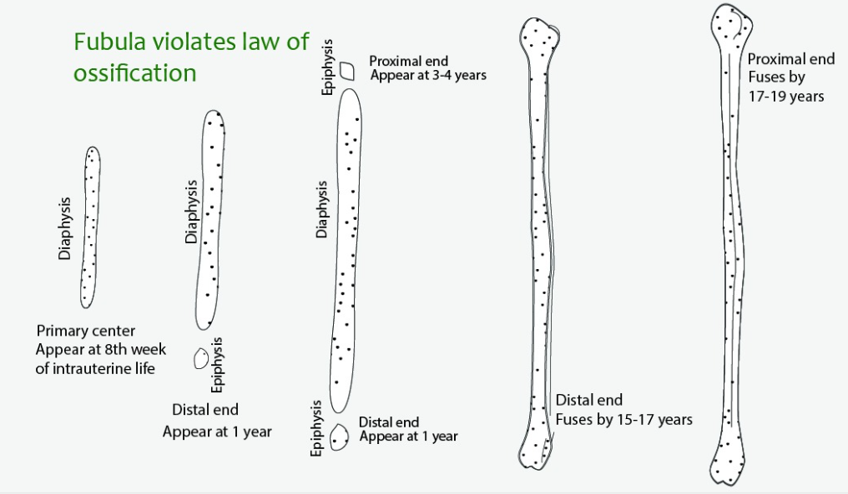

Sesamoid bones and accessory bones
Definition:
- Small sesame seed like bones
- Develop in the tendon of the muscles crossing the joint
- Acts as leverage to redirecting the contractile vectors crossing a joint

Examples
Patella in tendon of quadriceps femoris is the largest sesamoid bone
Fabella in the tendon of head of gastrocnemius
Sesamoid bones are present in tendons of flexor hallucis brevis
Pisiform in the tendon of flexor carpi ulnaris
Sesamoid bones are present in tendons of flexor pollicis brevis and adductor pollicis
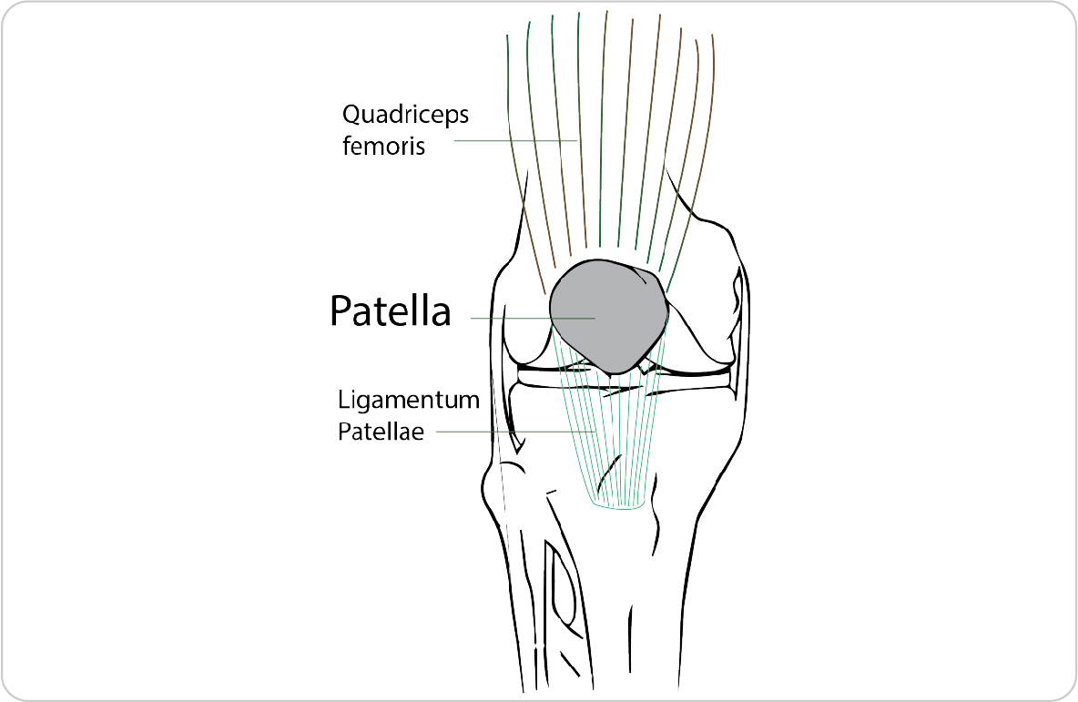
Features of sesamoid bones
- Not completely ossified
- Lack medullary cavity
- Ossification begins late in life
- Patella ossifies from several centers
Functions
- Modify the direction of force / pull of the muscles
- Reduce friction
- Maintains local circulation around a joint against pressure points
Applied aspects
- Fracture of patella to be treated by Wiring
- Sesamoid bones in foot can undergo subluxation, dislocation or fractures
- Small sesamoid bones in hand and foot can be misleading while evaluating fractures nearby bones
- Chronic stress fractures of the sesamoids, most commonly seen in long-distance runners and ballet dancers
Sesamoid bones of upper limb
1. Pisiform bone - flexor carpi ulnaris
2. Sesamoid bone in adductor pollicis
3. Sesamoid bone in flexor pollicis brevis
Sesamoid bones of lower limb
1. Patella - quadriceps femoris
2. Fabella - lateral head of gastrocnemius
3. Two sesamoid bones within two tendons of flexor hallucis brevis
4. Sesamoid bone within the popliteus tendon
5. Sesamoid bones may be present within the long tendons related to head of second and third metatarsals
6. Sesamoid bone at head of fifth metatarsal bone
7. Sesamoid of the interphalangeal (IP) joint of the great toe

Accessory bones or supernumerary bones
These are the bones that are not normally present, but can be found as variant in some individuals
While interpretting X-rays, possibility of accessory bones to be considered to avoid misdiagnosis of fracture
Os trigonum
- Represents the lateral tubercle of the posterior process of the talus bone that failed to fuse
- Present in ~7 to 25% normal individuals
Other accessory bones
In foot and ankle
1. Os perneum
2. Accessory navicular
3. Os calcaneus secundarium
4. Os intermetatarseum
In hand and wrist
1. Os ulnostyloideum
2. Os centrale
3. Os trapezium secundarium
4. Os styloideum

Case based questions
A child with growth disturbance after an injury
An 11-year-old child sustains an injury involving the distal tibial growth plate. During follow-up, imaging shows a bridge of bone across the medial part of the plate. The lateral part remains open. Over time, the ankle develops an angular deformity.
- Which normal developmental process has been interrupted?
- Why does continued growth on only one side produce angulation?
- Which cells normally produce the cartilage columns in the growth plate?
Growth after a childhood fracture
A 10-year-old child sustains a fracture near the lower end of the tibia. Imaging shows that the fracture crosses the growth plate.
- What type of cartilage forms the growth plate?
- How does this plate contribute to increasing bone length?
- If a bony bridge develops across only one side of the plate, what change in bone alignment could occur? Explain anatomically.
A small bone within a tendon
An X-ray taken after a knee injury shows that the patella is intact. The student examining the image notices that it lies within the quadriceps tendon.
- How is the patella classified?
- How does a bone in this position influence the action of the quadriceps?
- Why might a patellar fracture interrupt active knee extension even when the femur and tibia are intact?
Osteomyelitis in a child
A 7-year-old child presents with fever, a limp, and tenderness just above the knee. MRI shows osteomyelitis in the flared portion of the distal femur, immediately on the shaft side of the growth plate. Blood cultures confirm that bacteria are present in the bloodstream.
- Which region of the femur is infected? Where does it lie in relation to the diaphysis and epiphysis?
- What features of the blood supply make this region a common site for blood-borne infection in children?
- If the infection damages only one side of the adjacent growth plate, how could the shape of the limb change as the child grows?

Cartilage
Key points to remember:
- Cartilage is avascular: its chondrocytes receive nutrients by diffusion through the surrounding matrix.
- Hyaline, elastic, and fibrocartilage have different mechanical roles: smooth support, flexibility, and resistance to tensile and compressive forces, respectively.
- Perichondrium surrounds most cartilage, but is absent from articular cartilage and fibrocartilage.
- Cartilage has limited repair capacity, making damage to articular cartilage particularly important clinically.

Definition: Cartilage is a firm and flexible scleral connective tissue
General Features
- Support
- Avascular – nourishment by diffusion
- No nerves
- Poor regeneration
- Perichondrium – covering of cartilage
  - Except in articular cartilage and fibrocartilage
Growth of cartilage
- Appositional growth: From Perichondrium. Chondrogenic cells forms chondroblasts
- Interstitial growth: From deep chondrocytes

Hyaline cartilage
- Chondrocytes in lacunae appear either singly or in isogenous groups
- The interterritorial matrix stains less basophilic, whereas the territorial matrix around the lacunae stains more basophilic
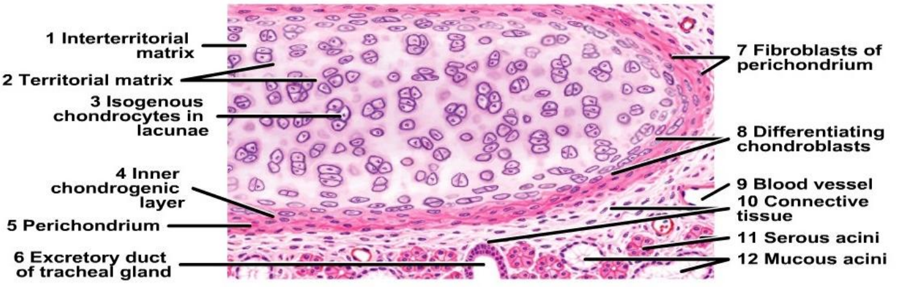
Figure: histology of hyaline cartilage
Hyaline cartilage examples
- Articular cartilage
- Epiphyseal cartilage
- Costal cartilage
- Tracheal rings
- Thyroid cartilage
- Cricoid cartilage
Articular hyaline cartilage
- Covers articular surfaces in synovial joints
- Extremely smooth, resistant surface
- Bathed by synovial fluid
- Dissipates stresses
- Gives flexibility
- Shock-absorber
- Resists the large compressive forces
- Articular cartilage does not ossify
- 1 to 7 mm in thickness
- Surface of articular cartilage lacks a perichondrium
- Synovial membrane overlaps

Applied anatomy
Osteochondrosis: disorders of actively growing epiphyses lack of vascularity that may be the result of trauma, infection, or congenital malformation.
- Osteochondrosis of the Navicular (Köhler Disease)
- Osteochondrosis of the Metatarsal Head (Freiberg Infraction)
- Epiphysitis of the Tibial Tuberosity (Osgood-Schlatter Disease)
Achrondroplasia
Point mutation in the fibroblast growth factor receptor 3 (FGFR3)
Activated FGFR3 inhibits chondrocyte proliferation
Normal epiphyseal growth plate expansion is suppressed, and long bone growth is severely stunted affects all bones that form from a cartilaginous framework

Elastic cartilage
- Elastic fibres enter the cartilage matrix from the surrounding connective tissue perichondrium and become distributed as branching and anastomosing fibres of various sizes
- Larger chondrocytes in lacunae are more prevalent in the interior
E.g. Ear pinna, external auditory meatus, auditory tube, epiglottis, corniculate and cuneiform
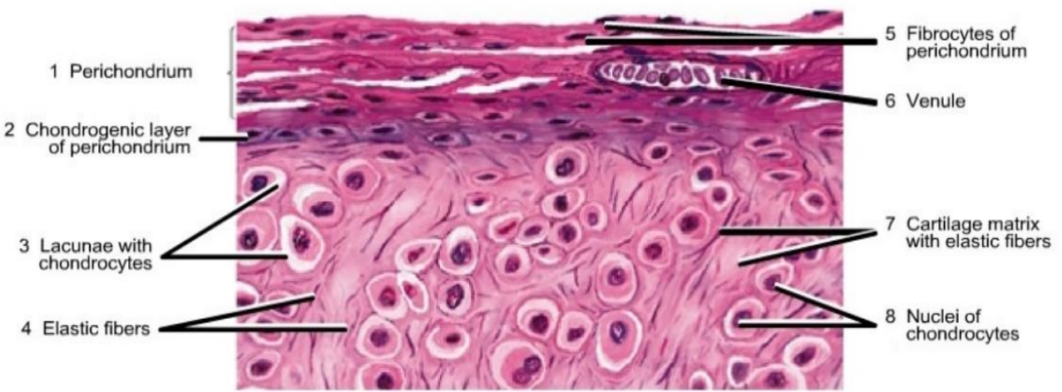
Figure: histology of elastic cartilage

Fibrocartilage
- The matrix is filled with dense collagen fibers with parallel arrangement
- Small chondrocytes in lacunae are distributed in rows within the fibrous cartilage matrix
- Perichondrium is absent
E.g. Intervertebral disc, glenoid and acetabular labrum
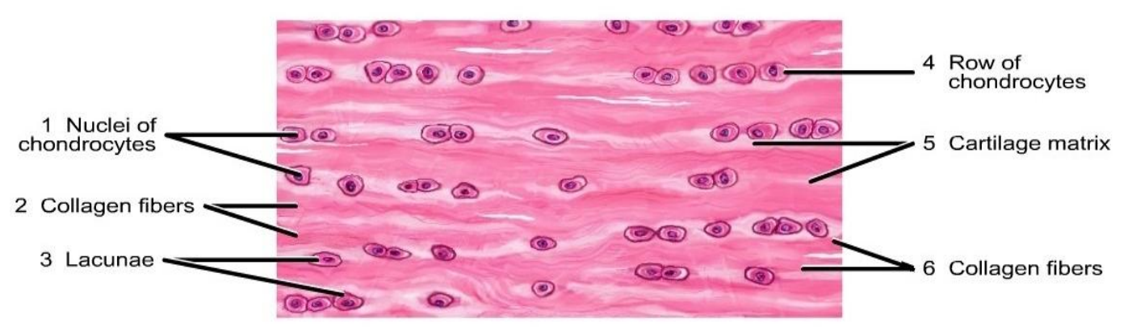
Figure: histology of fibrocartilage

e

Fascia and modifications of deep fascia
Connective tissue large enough to be seen by unaided eyes is fascia
Fascia is divided into
superficial fascia and deep fascia
Loose connective tissue that merges with deeper aspect of dermis is - Superficial fascia
Thickness of superficial fascia varies
Fascia between deeper structures is - Deep fascia
There are many modifications of deep fascia

Superficial fascia is absent in
- Eyelids
- External ear / pinna
- Penis
- Scrotum

Modifications of Deep fascia
Retinaculum
- Band around tendons that holds them in place
Eg: Flexor retinaculum of hand
Aponeurosis
- Sheet like expansion of the tendinous insertion of the muscle
Eg: Bicipital aponeurosis of biceps brachii attaches tendon of the muscle to medial aspect of the forearm
Aponeurosis of frontalis and occipitalis muscles forms the third layer of scalp
Fibrous sheath
- Connective tissue covering other structures
Eg: Carotid sheath covers great vessels of the neck
Fibrous capsules
- Connective tissue covering organs and glands
Eg: parotid sheath covers parotid gland
Intermuscular septa
- Connective tissue between the muscles
Eg: medial and lateral intermuscular septa divide arm into different compartments

Case based questions
Fluid in a swollen knee
A patient develops a swollen knee after an injury. Ultrasound demonstrates excess fluid within the joint cavity.
- How is the knee classified structurally?
- Which membrane lines the inner surface of its fibrous capsule, and which surface covering is excluded from that lining?
- Why can excess fluid distend the capsule and restrict movement?
Loss of shoulder stability
A patient sustains a shoulder dislocation. Imaging also shows injury to the fibrocartilaginous rim around the glenoid cavity.
- What is this rim called?
- How does it normally contribute to the relationship between the humeral head and glenoid cavity?
- Why may damage to it increase the likelihood of another dislocation?

General Considerations of skin
Key points to remember:
- Skin consists of epidermis and dermis: the underlying hypodermis connects it to deeper tissues.
- Thick skin occurs on the palms and soles
- A dermatome is an area of skin supplied predominantly by one spinal nerve, making sensory patterns useful in neurological assessment.
- Skin tension influences wound appearance: incision planning considers local tension lines, exposure, and protection of underlying structures.

Functions of skin
- Barrier against microbial invasion
- protect against mechanical, chemical, osmotic, thermal and UV radiation damage
- Immune surveillance
- Synthetic processes
- Target for hormonal action
- Body temperature regulation
- Sociosexual communication
- Major sense organ
- Friction and locomotion
Color of skin
Color of skin is determined by
- Melanin pigment
- Blood supply of skin
- Thickness of cornified layer
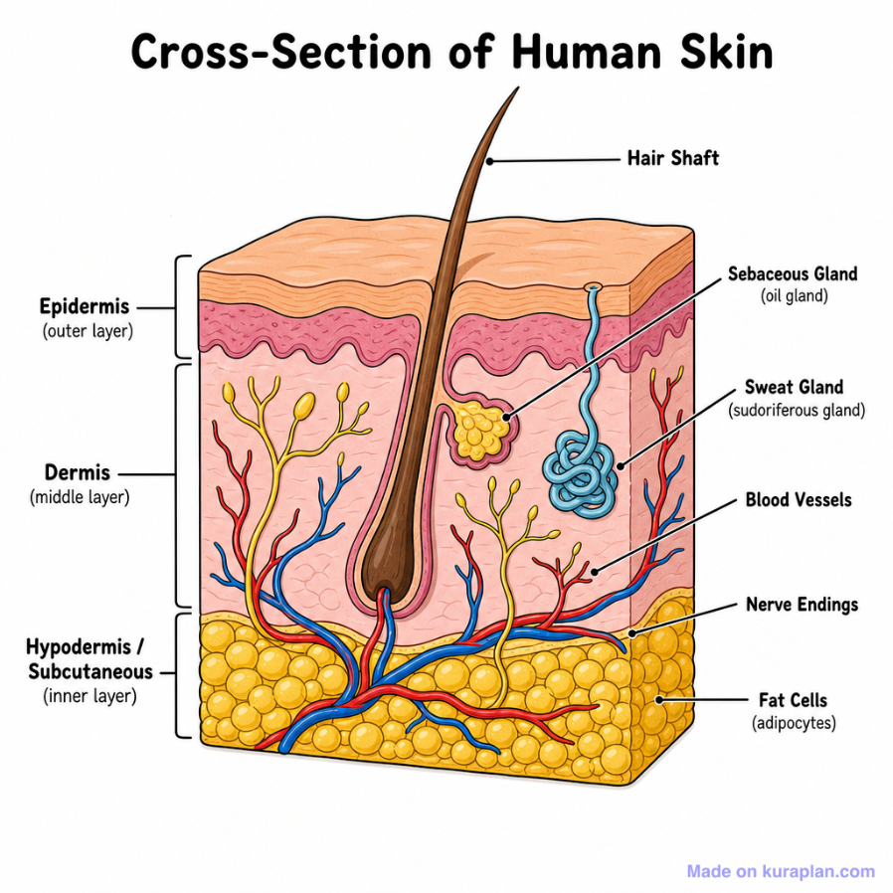
Layers of skin
- Outer - Epidermis
- Inner - Dermis
- Innermost - Hypodermis
Stratified squamous epithelium
Layers
- Stratum basale
- Stratum spinosum
- Stratum germinatum
- Stratum lucidum
- Stratum corneum
Dermis
- Has connective tissue, blood vessels, oil and sweat glands, nerves, hair follicles, and other structures
- Has two layers
  - Thin - upper papillary dermis
  - Thick - lower reticular dermis
Hypodermis
- Contains subcutaneous fat and is the superficial or subcutaneous fascia
Classification of skin
Based on thickness of cornified layer - stratum corneum
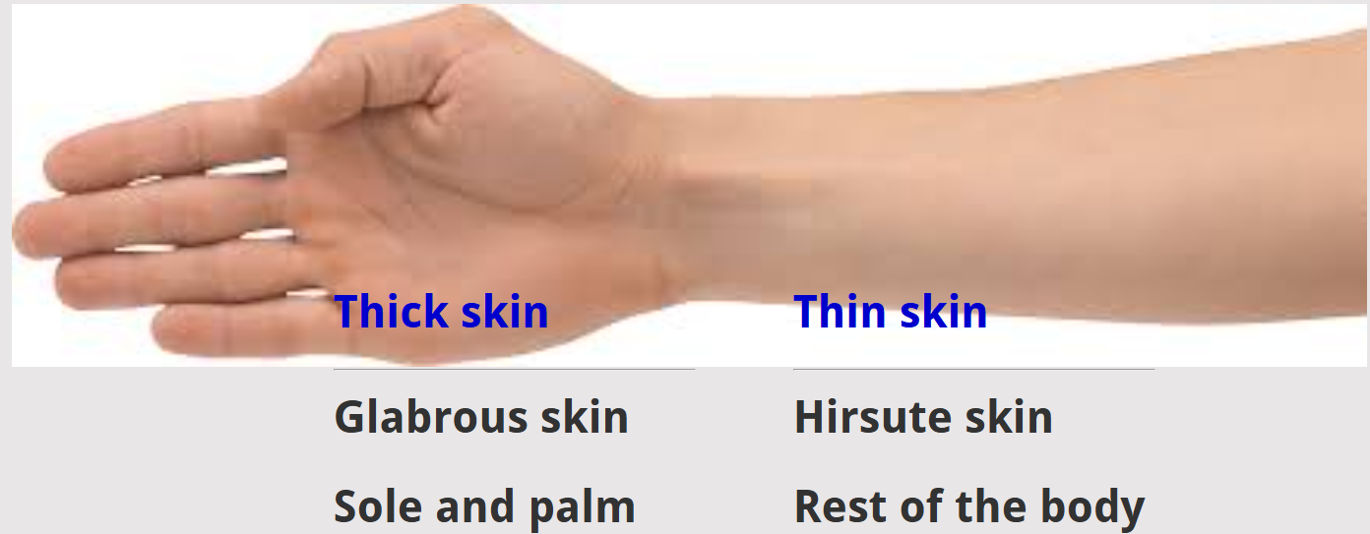
Thick skin
- Present in palm and sole
- In areas of high friction
- Has epidermal ridges
- Has more sudoriferous glands
- Has denser sensory receptors

Thin skin
- Present in rest of the body
  - Has hair follicles
- Arrector pilori muscle present
- Lacks epidermal ridges
- Has fewer sudoriferous glands
- Has sparcer sensory receptors

Skin appendages
- Hair
- Arrector pili
- Sebaceous glands
- Sweat glands
Skin lines
- Lattice pattern
- Wrinkle lines
- Flexure (joint) lines
- Papillary ridges
Papillary ridges
- Epidermal ridges correspond to an underlying interlocking pattern of dermal papillae
- Study of epidermal ridges is – Dermatoglyphics
Nerve supply to skin
- Nerves supplying skin are called - Cutaneous nerves
- Motor nerves - are responsible for glandular secretion and arrector pili contraction
- Sensory nerves - are responsible for general sensation
Dermatome
- Area of skin supplied by a single spinal nerve
Dermatome map
- Most books use dermatome maps as described by Foerster or Keegan and Garrett (1948)
- This map was derived from examining compression of dorsal nerve roots by vertebral disc herniation
- Earlier maps were from experiments performed on cadavers and monkeys
- Wide disparity exists in dermatome maps
Embryology
- After formation of segments during somatization, different somites are formed
- Each somite - shows dermatomal, sclerotomal and myotomal patterns.
- Some total of skin (dermatomal part) of the somite is supplied by respective spinal segment
Clinical aspects - dermatome
Understand the radiation of pain
- In case of compression of the nerve root
- Referred pain - cardiac ischemic pain is referred to the inner aspect of left upper limb (T1 dermatome)
Spread of Varicella zoster virus in herpes zoster
- Varicella virus (neurotrophic virus) remains dormant in the dorsal root ganglion after chicken pox infection.
- Upon reactivation (as in immunocompromised states) the virus spreads along the respective dermatome
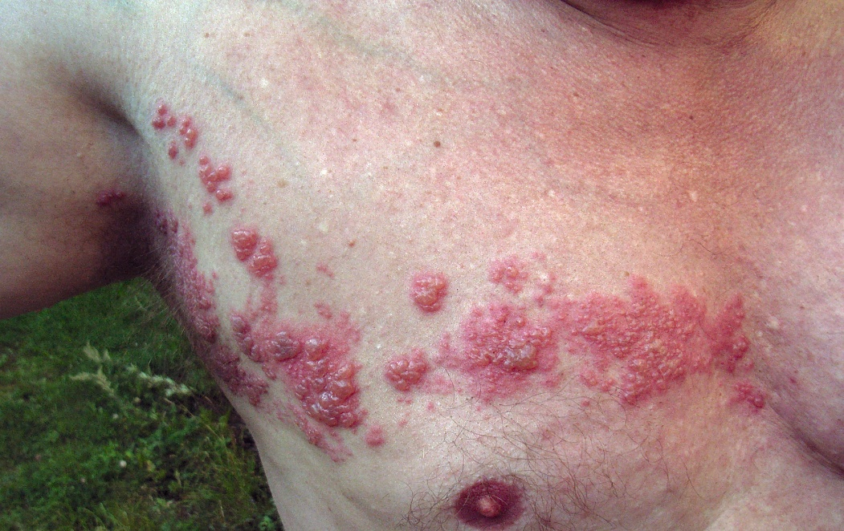
Figure : Varicella Zoster spreading along a thoracic dermatome.

Skin incisions
Definition - surgical skin incision
A surgical incision is the cut made in the skin and superficial tissues to facilitate the surgical procedure
Three essential factors to be considered before incising
- Accessibility
  - The incision should allow the surgeon to access the part required completely
- Extensibility
  - Incision should be extensible if required
- Security
  - Incision should not injure surrounding structures
Principles of skin incision
- Should be long enough for good exposure
- Nerves and vessels should not be injured
- Splitting is better than cutting
- Transverse incisions are better than the vertical incisions
- Wound closure - be done in layers
Cleavage lines (Langer's lines)
Langer's lines correspond to the natural orientation of collagen fibres in the dermis
They are parallel to the orientation of the underlying muscle fibres
Skin incisions perpendicular to Langer's Lines have been described to have a poorer final cosmetic appearance compared to those along Langer's Lines
Wrinkle lines (Kraissl's lines)
Oriented perpendicular to the action of the underlying muscles
coincides with wrinkle lines
Skin incisions parallel to Kraissl's lines result in better cosmetic outcome
Relaxed Skin Tension Lines
On pinching the relaxed skin, furrows and ridges are noted.
The lines thus produced are relaxed skin tension lines
Follow wrinkle lines
Skin incisions be made along
Current concept
Wrinkle lines and Relaxed Skin Tension Lines largely coincide and should be used instead of Langer’s lines for planning incisions
Ref:
1. Waldorf JC, Perdikis G, Terkonda SP. Planning incisions. Oper Tech Gen Surg. 2002 Sep 1;4(3):199–206.
2. Paul SP. Biodynamic Excisional Skin Tension (BEST) Lines: Revisiting Langer’s Lines, Skin Biomechanics, Current Concepts in Cutaneous Surgery, and the (lack of) Science behind Skin Lines used for Surgical Excisions. J Dermatol Res. 2017 Mar 10;2(1):77-87–87.

Dermatoglyphics
Definition
Study of configurations of epidermal ridges on palms, fingers, soles, and toes
Etymology
Greek: derma = skin, glyph = carving
Development
Dermatoglyphic pattern is established during 10th week of intrauterine life
Complete adult like pattern can be appreciated as early as 24th week of development
Uniqueness
Fingerprint pattern is unique to every individual
Pattern remains constant throughout life
Follow polygenic pattern of inheritance
Papillary ridges
Are the surface ridges of epidermis
Sweat pores open here
Increases the grip by increasing friction
Epidermal ridges reflect contours of the underlying dermal papillae and form the basis for fingerprints
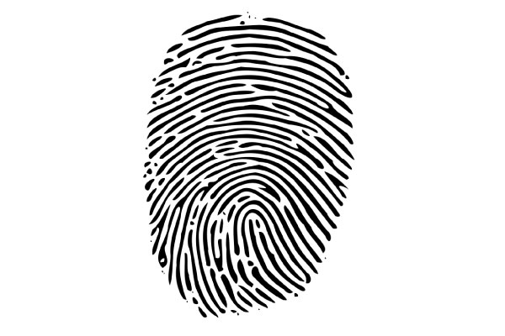
Figure: Fingerprint pattern -Arches - Parallel ridges

Fingerprint Pattern Configurations
Arches
- Parallel ridges
- Two patterns - simple arches and tented arches
Loops
- Ridges enter the pattern area, curve abruptly and leave the pattern
- Can be ulnar loops and radial loops
Whorls
- Ridges encircling a cone
Composites
- Combination of two or more configurations
- Two patterns- arch with loop and arch with whorls
Uses of dermatoglyphics
- Diagnosis of Medical Disorders
- Klinefelter syndrome - significant lesser total finger ridge count
- Down syndrome - mainly ulnar loops, altered 'atd' angle, simian crease
- Turner syndrome - Predominance of whorls
- Male catatonic schizophrenia - more arches and less whorls
Fingerprints and biometrics
Biometrical authentication is the process of making sure that the person is who he claims to be.
Fingerprint pattern recognition is the oldest and popular biometric method
Fingerprint biometrics involves comparing two examples of friction ridge skin impression from human fingers, palm or toes
This is the basis of Aadhar card biometrics from Unique Identification Authority of India (UIDAI)

Case based questions
A superficial abrasion
A student scrapes the palm against a rough surface. The clinician confirms that the abrasion is confined to the epidermis and does not bleed.
- What type of epithelium forms the epidermis?
- Why does an injury confined to this layer usually produce no bleeding?
- If the injury extends into the dermis, which additional structures could be damaged to produce bleeding and altered sensation?
A band of skin blisters
A patient develops painful blisters in a narrow band around one side of the chest. The clinician explains that the eruption follows a dermatome.
- What is a dermatome?
- Where are the cell bodies of the sensory neurons supplying this skin located?
- Why can a disorder involving one sensory ganglion produce a band-like skin distribution rather than involve the entire trunk?

Joints
Key points to remember:
- Joints are structurally classified as fibrous, cartilaginous, or synovial, according to the tissues connecting the skeletal elements and the presence of a cavity.
- A typical synovial joint has articular cartilage, a joint cavity, synovial fluid, and a capsule with an inner synovial lining.
- Joint shape influences permitted movement, while ligaments, muscles, and the fit of the articulating surfaces contribute to stability.
- Primary cartilaginous joints contain hyaline cartilage; secondary cartilaginous joints contain an intervening fibrocartilaginous component.
Classification of joints
Fibrous joints
- Lacks intervening cartilage between bones
- Fixed
- Very restricted movements
Cartilaginous joints
- Have a cartilage in between the articulating parts
- Relatively mobile
- Restricted movements

Synovial joints
- Bones involved are linked by a fibrous capsule
- Articulating bony surfaces are generally not in direct continuity
- Covered by hyaline articular cartilage of varying thickness
- Very low coefficient of friction- free movement
- Viscous synovial fluid - acts as a lubricant + cellular maintenance
- Synovial membrane - defining characteristics of the joint type
Synovial joints - general features
Typical features of a synovial joint
- Bones involved are linked by a fibrous capsule
- Articulating bony surfaces are generally not in direct continuity
- Covered by hyaline articular cartilage of varying thickness
- Very low coefficient of friction- free movement
- Viscous synovial fluid - acts as a lubricant + cellular maintenance
- Synovial membrane - defining characteristics of the joint type
Articular surfaces
- Formed by a specialization of hyaline cartilage
- Parts of cartilaginous models in embryonic life
- Articular cartilage has a wear-resistant, low-frictional, lubricated surface
- Compressible and elastic
- Ideally constructed for easy movement
- Young cartilages are typically white, smooth, glistening and compressible,
- Ageing cartilages are thinner, less cellular, firmer and more brittle, with a less regular surface and a yellowish opacity
Fibrous capsule
- Completely encloses a joint except where it is interrupted by synovial protrusions
- Composed of interlacing bundles of parallel fibres of white collagen
- Attached continuously round the ends of the articulating bones
- Capsule is perforated by vessels and nerves
- It is lined by a synovial membrane
- Fibrous capsule usually exhibits local thickenings - capsular (intrinsic) ligaments
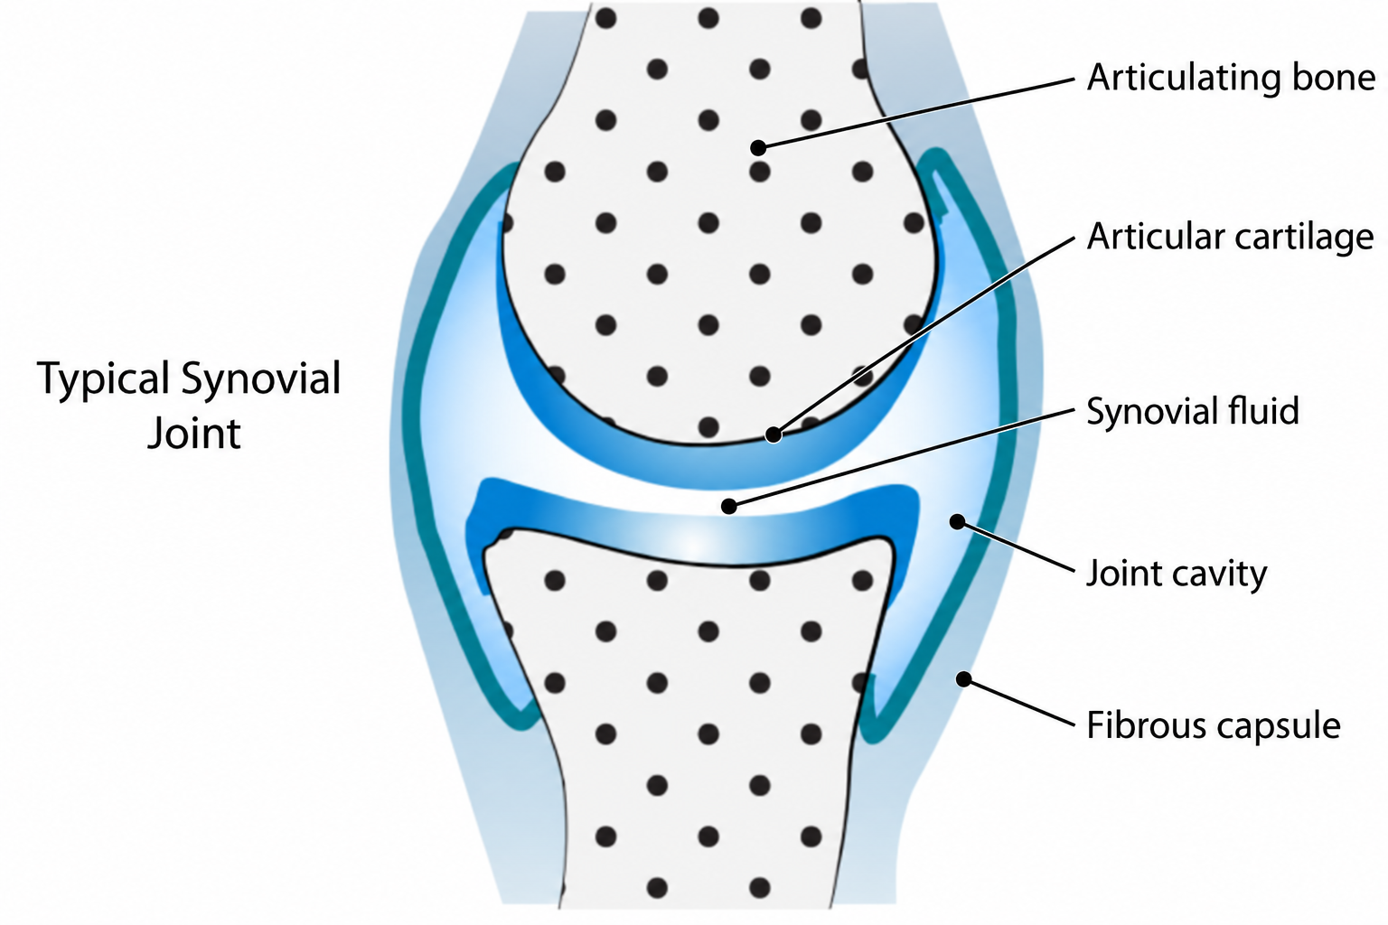
Figure: typical synovial joint
Synovial membrane
- Lines fibrous capsules and covers exposed osseous surfaces, intracapsular ligaments, bursae and tendon sheaths
- It does not cover intra-articular discs or menisci and stops at the margins of articular cartilages
- Synovial membrane secretes and absorbs a fluid that lubricates the movement between the articulating surfaces.
- Composed of a cellular intima resting on a fibrovascular subintimal layer (subsynovial tissue).
- Synovial cells are generally elliptical and have numerous cytoplasmic processes.
- Type A and type B synovial cells, are responsible for synthesizing some of the components of the synovial fluid.
- Type A cells are macrophage-like cells
- Type B synovial cells resemble fibroblasts
- Type B synovial cells – predominate
Synovial fluid
- Occupies synovial joints, bursae and tendon sheaths
- Clear or pale yellow, viscous, slightly alkaline at rest (the pH lowers during activity), and contains a small mixed population of cells and metachromatic amorphous particles
- Fluid volume is low: usually less than 0.5 ml can be aspirated from a large joint such as the knee.
- Composition
  - Protein (approximately 0.9 mg/100 ml)
  - Hyaluronan - determinant of the viscoelastic and thixotropic (flow rate dependent) properties
  - Synovial protein - produced by synovial type B cells
  - Specialized lubricating glycoprotein
  - Few cells (approximately 60 per ml in resting human joints), including monocytes, lymphocytes, macrophages, synovial intimal cells and polymorphonuclear leukocytes: higher counts are found in young individuals
Intra-articular menisci, discs and fat pads
- Consists of fibrocartilage where the fibrous element usually predominates, and is not covered by synovial membrane.
- Nomenclature
  - Term 'Meniscus' should be reserved for incomplete discs, like those in the knee joint and, occasionally, in the acromioclavicular joint.
  - Complete discs, such as those in the sternoclavicular and inferior radio-ulnar joints, extend across a synovial joint, dividing it structurally into two synovial cavities; they often have small perforations.
  - The disc in the temporomandibular joint may be complete or incomplete.
  - Labrum is a fibrocartilaginous annular lip, usually triangular in cross-section, attached to an articular margin (e.g. Glenoid fossa and acetabulum).
  - Fat pads are soft and change shape to fill joint recesses that vary in dimension according to joint position
- Disc is relatively acellular
Vascular supply and lymphatic drainage
- Periarticular arterial plexuses whose numerous branches pierce the fibrous capsules to form subsynovial vascular plexuses.
  - The circulus articularis vasculosus
- Lymphatic plexus in the synovial subintima drains along blood vessels to the regional deep lymph nodes.
Innervation
Hilton’s law - A movable joint is innervated by articular branches of the nerves that supply the muscles acting on the joint and that also supply the skin covering the joint
Each nerve innervates a specific part of the capsule.
- Region made taut by muscular contraction is usually innervated by nerves that supply the antagonists
- Myelinated axons in articular nerves innervate Ruffini endings, lamellated articular corpuscles and structures resembling Golgi tendon organs
Classification of synovial joints
1. Plane synovial joint: Intermetacorpal joints
2. Hinge joints: Interphalangeal joints
3. Pivot joints: Superior radioulnar joint
4. Bicondylar joint: Knee joint
5. Ellipsoid joint: Radiocarpal joints, Metacarpophalangeal joints
6. Saddle joint: Carpometacarpel joint of thumb, Ankle joint, Calcaneocuboid joint
7. Ball and socket: Hip joint and Shoulder joint

Applied aspects
Few disorders are specific to synovial joints
Inflammation of synovial membrane
1. Rheumatoid arthritis
2. Seronegative spondyloarthropathies (psoriasis, Reiter syndrome, and ankylosing spondylitis)
Synovial joints may under internal derangements
Eg: Injury to intra-articular disc, cartilage, labrum and menisci
Trauma may lead to synovial effusion
Fibrous joints
Classification
- Sutures
- Syndesmosis
- Gomphosis
Sutures
- Present in vault of Skull
- Bones separated by a layer of membrane derived from connective tissue
Eg: Sagittal suture, Coronal suture
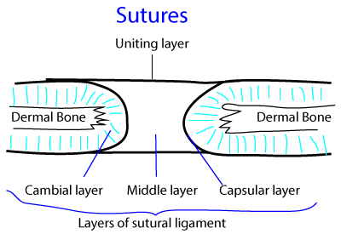
Figure: sutural joint in the cranial vault
Syndesmosis
- True connective tissue between the bones
  - Interosseous membrane
  - Slender fibrous cord
  - Dense aponeurotic membrane
    - Posterior part of sacroiliac joint
Eg: distal tibiofibular joint and radioulnar joint
Gomphosis
- Peg and socket junction between the tooth and its socket
- Not an articulation between two skeletal elements
Synindyesis
- Specialised suture
- A rigid bone fits into a groove neighbouring element
E.g. cleft between alae of vomer receives the rostrum of sphenoid

Cartilaginous joints
1. Primary cartilaginous joints
- Where advancing centers of ossification are separated by an area of hyaline cartilage
- Present in all post-cranial bones that ossify from more than one center
- Synchondrosis later forms synostosis
2. Secondary cartilaginous joints
- Intervening pad/disc of fibrocartilage interposed between articular hyaline cartilage
- Combined strength of ligament + hyaline + fibrocartilage exceeds that of bones
- Designed to withstand range of stresses
- Movements limited

Symphysis
A joint in which the body (physis) of one bone meets the body of another
All symphyses occur in midline
Examples are
- Mandibular symphysis
- Manubriosternal joint
- Pubic symphysis
- Intervertebral joints
General rules about symphysis
- All symphyses occur in midline
- All are postcranial – except mandibular symphysis
- All resist synostosis – except mandibular symphysis
Applied aspects
- Postpartum pubic symphysis diastasis (PPSD) refers to the separation of pubic symphysis after delivery
- The gap of symphysis pubis is usually 4-5 mm and the gap is slightly increased during pregnancy
- Hormone relaxin remodel the ligamentous capsule of pubic symphysis and allows a more flexible joint during delivery of the baby
- By examining the wear of the pubic symphysis, it is possible to estimate the age of the person at death
Case based questions
Fluid in a swollen knee
A patient develops a swollen knee after an injury. Ultrasound demonstrates excess fluid within the joint cavity.
- How is the knee classified structurally?
- Which membrane lines the inner surface of its fibrous capsule, and which surface covering is excluded from that lining?
- Why can excess fluid distend the capsule and restrict movement?
Loss of shoulder stability
A patient sustains a shoulder dislocation. Imaging also shows injury to the fibrocartilaginous rim around the glenoid cavity.
- What is this rim called?
- How does it normally contribute to the relationship between the humeral head and glenoid cavity?
- Why may damage to it increase the likelihood of another dislocation?

Vascular system
Key points to remember:
- Arteries carry blood away from the heart and veins return it: these names describe flow direction, rather than oxygen content.
- Arterioles regulate resistance, capillaries permit exchange, and veins serve as major blood reservoirs.
- Anastomoses provide alternative routes for blood flow, but their ability to preserve tissue depends on the adequacy of the collateral circulation.
- Thrombosis forms a clot within the circulation; embolism carries material to another site: either can obstruct vessels and compromise tissue survival.
General organization
Vessels: Tubes that carry blood
Arteries: Vessels carrying blood away from the heart
Veins: Vessels carrying blood towards the heart
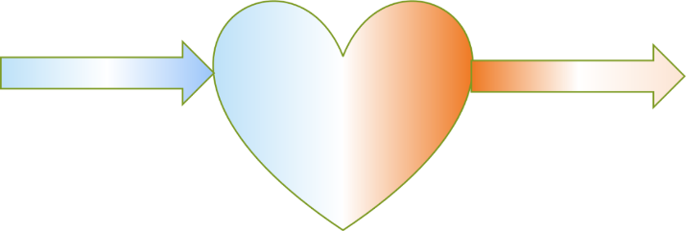
Vein
Artery
General characteristics of arteries
- Pulsatile
- Thick walled
- Smaller lumen
- Empty
- Single
- Deep
- Pinkish red
General characteristics of Veins
- Large lumen
- Thin walled
- Superficial
- Multiple
- Variable
- Have clot
- Blackish, blue
- Valve +
Vessels – types
Resistance vessels
- Arteries, but mainly arterioles
Exchange vessels
- Capillaries, sinusoids and small venules
Capacitance vessels
- Veins
Arteriole
Thoroughfare channels measuring 100 microns in diameter

Meta-arteriole
- Small vessels linking arteriole and capillaries
- Tunica media shows - intermittent smooth muscles forming
- Precapillary sphincters
Pre-capillary sphincters
- Band of smooth muscles at the beginning of capillaries
- Regulate blood flow into the capillary bed
- Especially appreciated in the mesenteric circulation
Microstructure of vessels
Wall of the vessel has three layers
- Tunica intima - Inner most layer of the vessel, Made of simple squamous epithelium
- Tunica media - thickest layer of the vessel, Made of either smooth muscles or elastic fibres
- Tunica Adventitia - Outer most layer of the vessel. Made of loose areolar tissue. Has small blood vessels supplying the wall - vasa vasorum
Elastic artery - Large sized artery
- Has predominantly elastic fibres in tunica media
- Aorta, pulmonary trunk and stem of great vessels in mediastinum are elastic arteries
Muscular artery - medium sized artery
- Has predominantly smooth muscles in tunica media
- Radial artery, femoral artery, coronary artery and all peripheral vessels are muscular arteries

Vascular Anastomosis
Vascular anastomosis: a cross-connection between adjacent channels of a vascular network
Anastomoses - pleural
Types
- Arterial anastomosis
- Venous anastomosis
- Arteriovenous anastomosis
Collateral circulation
- Alternative circulation due to presence of anastomoses is collateral circulation
Arterial anastomosis
- Communication between arteries
- Communicating channels may be actual anastomosis or potential anastomosis
Eg:
Circle of Willis at the base of the brain
Anastomosis around elbow joint and scapula
Venous anastomosis
- Communication between veins
- Communicating channels may be actual anastomosis or potential anastomosis
Eg:
Dorsal venous arch of hand and foot
Median cubital vein connecting cephalic and basilic veins
Arteriovenous anastomosis
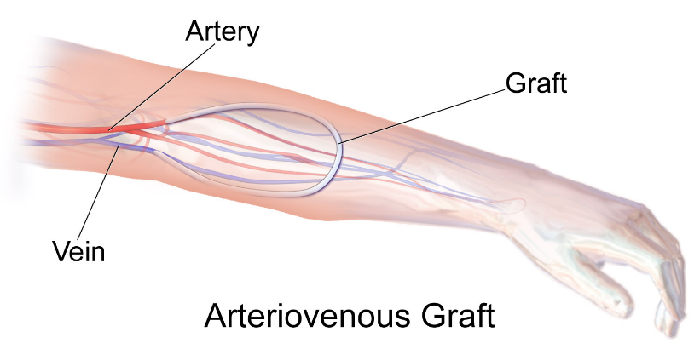
- Communication between artery and vein
- Communicating channels may be actual anastomosis or potential anastomosis
- They contain no capillary segment
- Function: Thermoregulation. Transport of heat from the body core to surface areas containing arteriovenous anastomosis
Eg:
Numerous arteriovenous anastomosis present in the glabrous skin of the hands and feet
Arteriovenous fistula
- Definition: An abnormal communication between artery and vein
- It is surgically created in patients requiring haemodialysis
- Such Arteriovenous fistula provides long-lasting access through which blood can be removed and returned during haemodialysis

Sites of Arteriovenous fistula for haemodialysis:
Usually created in non-dominant hand
In forearm - Radiocephalic fistula. Radial artery anastomosed with cephalic vein
At elbow - brachiocephalic fistula. Brachial artery anastomosed with cephalic vein
In hand - Snuffbox fistula
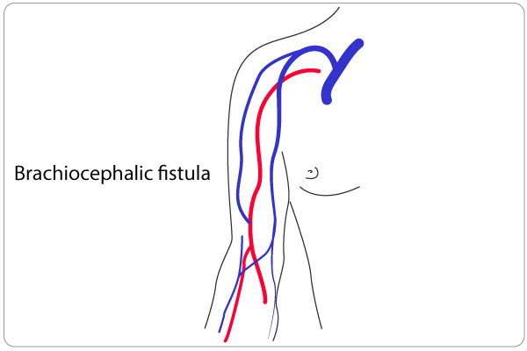
End arteries
Definition
Arteries that do not anastomose with any other arteries are end arteries
Examples
- Splenic artery supplying spleen
- Coronary arteries: Though there exists many anatomical anastomoses between right and left coronary arteries, they are not functional. So coronary arteries are end arteries.
Significance
- Occlusion of end arteries leads to failure of blood supply to the part concerned.
- This leads to ischemic death of that part
Eg: Coronary artery occlusion leads to ischemic death of myocardium (myocardial infarction)

Thrombosis
Thrombosis
Formation of clot (thrombus) in an uninjured vessel
Haemostasis
Tightly regulated process maintaining the blood in a fluid, clot-free state in normal vessels.
Three components of haemostasis and thrombosis
Vascular wall
Intact endothelial cells maintain liquid blood flow by
- Inhibiting platelet aggregation
- Prevent coagulation factor activation
- Lyse blood clots
Injured/inflamed endothelium contribute to the formation of thrombus by
- Expression of tissue factor and von Willebrand Factor (vWF)
- Exposure of basement membrane collagen

Platelets
- Injured endothelium exposes basement membrane and extracellular matrix
- Platelets adhere to this and secrete thomboxane A2
- Platelets aggregate and activate thrombin

Coagulation cascade
- Involves sequential enzymatic conversion of circulating and local proteins
- In the final stage - thrombin converts fibrinogen to fibrin
- Fibrin forms definitive haemostatic plug

Three important factors influencing thrombosis
- Endothelial injury
- Abnormal blood flow - statis or turbulence
- Hypercoagulability

Venous thrombosis
- Clot formation in the deep veins of the leg - is Deep Venous thrombosis (DVT)
- Deep thrombi in the larger veins of the lower limb can embolize to right side of the heart and into the pulmonary circulation
Arterial thrombosis
- Atherosclerosis - major initiator of the thromboses
- Left sided cardiac thrombosis can embolize to brain and kidney
Embolism
- Embolus is the detached intravascular and gaseous mass
- These masses are carried to distant places from their point of origin
Thromboembolism
- Thrombus that gets dislodge into the circulation
- Pulmonary thromboembolism
  - Thrombus in the veins and right side of the heart can get into the pulmonary circulation
- Systemic thromboembolism
  - Thrombus in the left side of the heart and major arteries can embolize into the brain and kidney
Other forms of embolism
- Fat embolism
- Air embolism
- Amniotic fluid embolism
Infarction
- Ischemic necrosis (death) of a tissue due to lack of arterial supply or venous drainage
- Ischemic necrosis of part of myocardium due to blockage of coronary arterial circulation is myocardial infarction
- Especially important in tissues supplied with end arteries and not having alternative arterial supply
Like – Heart, Brain, Kidney and Retina
Aneurysm
- A balloon like bulge in the artery due to weakness in its wall
- Most common site of central arterial aneurysm - abdominal aorta between the renal arteries and common iliac arteries
- Most common site of peripheral arterial aneurysm - popliteal artery behind knee joint

Case based questions
A connection created for dialysis
A patient requiring haemodialysis has a direct surgical connection created between an artery and a superficial vein in the forearm.
- What is this connection called?
- How does the direction of blood flow normally distinguish an artery from a vein?
- Why does connecting an artery to a vein make the vein more suitable for repeated vascular access?
A clot travels from the leg
A patient develops a thrombus in a deep vein of the leg. Part of the thrombus detaches and travels in the bloodstream.
- What is a detached, travelling fragment of a thrombus called?
- Trace its route from the inferior vena cava through the heart to the pulmonary circulation.
- Why is the pulmonary arterial circulation the expected destination rather than the systemic arterial circulation in a person without an abnormal cardiac communication?

Muscles
Key points to remember:
- Skeletal and cardiac muscle are striated; smooth muscle is non-striated. Their cellular organisation suits their different functions.
- Epimysium surrounds a muscle, perimysium surrounds its fascicles, and endomysium surrounds individual muscle fibres.
- Muscles act as agonists, antagonists, synergists, or fixators, depending on their contribution to a particular movement.
- Muscle action depends on attachment and line of pull: loss of motor innervation impairs contraction and can lead to denervation atrophy.

General considerations, classification, development, histology and functions of muscles
Definition: Muscle is a contractile tissue
- Contractile elements in the muscle cells brings about change in shape.
- Muscle contraction results in change in tension - generating sites within the muscle fibre
Characteristics of muscle
- Excitability
- Contractility
- Extensibility
- Elasticity
Developmental origin of muscle
- Mesoderm - Majority of muscles including skeletal, cardiac and smooth muscles develop from mesoderm
- Ectoderm - Sphincter pupillae and dilator pupillae of iris develop from ectoderm
- Endoderm - Myoepithelial cells are endodermal in origin

Structural classification of muscles
- Striated muscles
  - myosin and actin filaments are organized into regular, repeating elements which give the cells a finely cross-striated appearance
  - Skeletal muscle and Cardiac muscle
- Non-Striated muscles
  - Smooth muscle

Smooth muscle
- Cells are elongated - spindle shaped with central nucleus
- Derived from mesoderm
- Present in wall of gastrointestinal system, urogenital system, respiratory system, tunica media of vessels, in dermis (arrector pilori), intrinsic muscles of eye, dartos muscle of scrotum.
- Supplied by autonomic nerves
- Involuntary
- Has ability to contract for sustained contraction without fatigue
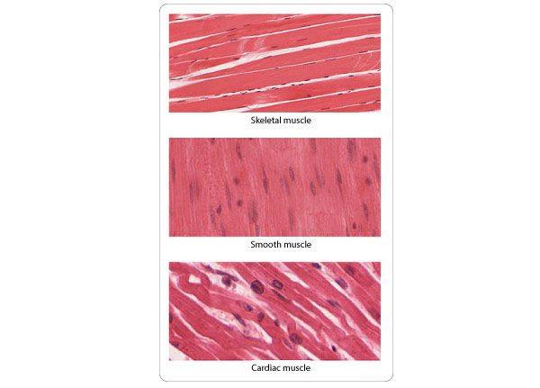
Figure: types of muscles

Cardiac muscle
- Short branching cells with central nucleus
- Faint striations present
- Present in heart
- Supplied by autonomic nerves
- Involuntary
- Autorhythemic
- Intercalated discs between cells help in fast conduction of impulses
- Specialised cell junctions – gap junctions
- Electrical syncytium

Skeletal muscle
- Separate cylindrical cells forming syncytium (hence multinucleated)
- Peripherally placed nucleus (contractile apparatus pushes the nuclues peripherally)
- Striations are well appreciated
- Alternate dark and light bands
- Each muscle fibre is made of – myofibrils
- Myofibrils composed of myofilaments having actin and myosin proteins
- Supplied by spinal nerves
- Voluntary
- Usually attached to skeleton - hence the name skeletal muscles
Cell membrane and cytoplasmic organelle of muscles are named differently
- Plasma membrane – sarcolemma
- Cytoplasm –sarcoplasm
- Smooth ER – sarcoplasmic reticulum
Connective tissue covering
Epimysium
•Surround entire muscle
Perimysium
•Cover muscle fascicles
Endomysium
•Individual muscle fibres

Terminology - Origin and insertion
Origin - Relatively fixed end
Insertion - Relatively moving end

Tendon
Fibrous connective tissue which attaches muscle
To the bone (not always)

Classification based on action
Slow contracting muscles
Type I
Fast contracting muscles
Type II
Classification based on action
Prime movers – agonists
- Working muscle
Antagonist
- Relaxing muscle
Synergists
- Contracting together
Fixators
- Provide support

Shunt muscles Vs Spurt muscles
A spurt muscle's origin is distant from the joint, but its insertion is close to the joint axis, providing a large rotational/mobility component (accelerating movement), whereas shunt muscles primarily provide a transarticular compressive/stabilizing vector along the moving bone.
Case based questions
A torn tendon
A patient sustains a complete rupture of the tendon connecting the calf muscles to the heel. The calf muscles can contract, but pushing the foot down against resistance is markedly weakened.
- What tissue forms a tendon?
- How does a tendon normally transmit the effect of muscle contraction?
- Why does contraction of the intact muscle fail to produce its usual movement when the tendon is completely ruptured?
Weakness after motor nerve injury
Following an injury, the motor nerve supplying a skeletal muscle is interrupted. The muscle becomes weak and gradually loses bulk.
- What is the term for loss of nerve supply to a muscle?
- Name the connective tissue coverings of an entire muscle, a fascicle, and an individual muscle fibre.
- Why can the muscle lose active function even though these connective tissue coverings and its tendon remain intact?

Parallel and pennate arrangements
Arrangement | How the fascicles run | Functional advantage | Example
Parallel | In the general direction of the muscle’s long axis | Long fibres can shorten over a greater distance, allowing greater excursion | Sartorius
Pennate | Obliquely to the tendon, like the barbs of a feather | More fibres can be packed side by side into a given muscle volume, favouring force production | Rectus femoris

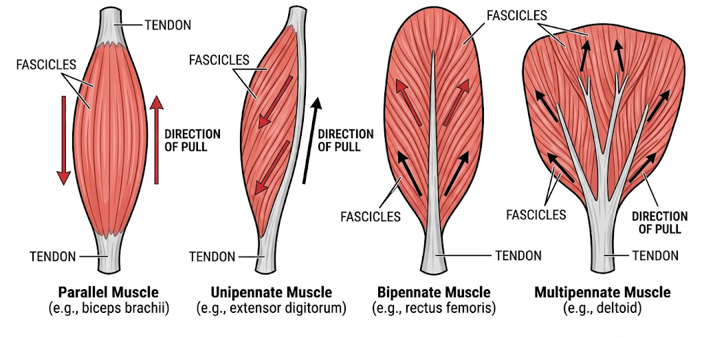

Tendon and aponeurosis - transmit force generated by muscle
- A tendon is a collagen-rich connective tissue structure that commonly has a cord-like form.
- An aponeurosis is a broad, flat sheet of tendinous tissue that can distribute force across a wide area
Agonist, antagonist, synergist and fixator
These terms describe a muscle’s role in a particular task. Consider lifting a cup towards the mouth by flexing the elbow, with the forearm supinated and the upper arm held at the side.

Role | Meaning | Example during the cup lift
Agonist | Produces the movement being studied | Brachialis flexes the elbow.
Antagonist | Can produce the opposing movement | Triceps brachii extends the elbow. It can also help control the movement through co-contraction.
Synergist | Assists the movement or limits an unwanted action | Biceps brachii assists elbow flexion in this forearm position.
Fixator | Stabilises a proximal part so the movement can occur from a steady base | Scapular stabilisers, including trapezius and serratus anterior, help steady the scapula against the thorax.
The distinction between a synergist and a fixator lies in what each contributes to the task. Biceps adds to the pull that bends the elbow. The scapular stabilisers hold the shoulder girdle steady while the forearm moves.
Research insight
Skeletal and cardiac muscle both contract, but their cells are specialised for different tasks. Myoblasts are precursor cells that normally form skeletal muscle fibres. Can researchers redirect these cells towards a cardiac fate?
Skeletal-to-Cardiac Conversion Barriers: Unlike fibroblasts, skeletal muscle precursors express striated contractile elements, but they are committed to cell fusion into multinucleated syncytia driven by basic helix-loop-helix (bHLH) factors (MyoD, Myogenin). Reprogramming requires repressing MyoD/Myogenin while ectopic cardiac master genes remodel chromatin loci for intercalated disc and gap junction assemblies.
Transdifferentiation (Direct Cardiac Reprogramming): Direct lineage reprogramming converts non-myocytes (resident cardiac fibroblasts or skeletal myoblasts) directly into induced cardiomyocyte-like cells (iCMs) without reverting to an intermediate pluripotent state.
Modern histological and diagnostics distinguishes muscle lineages via lineage-determining transcription factors, structural isoforms, excitation-contraction coupling complexes, and junctional proteins.
Skeletal Muscle as an Endocrine Organ:
- Skeletal muscle is now characterized beyond locomotion as a secretory organ.
- Muscle fibers secrete myokines (e.g., Irisin, Myostatin, IL-15) during contraction, which cross-talk with adipose tissue, liver, bone, and the central nervous system.
Satellite Cell Dynamics & the "Myonuclear Domain" Hypothesis:
- Pax7⁺ satellite cells reside between the sarcolemma and basal lamina.
- During hypertrophy, satellite cells fuse into existing myofibers to contribute fresh nuclei, maintaining a stable ratio of transcriptional capacity to cytoplasmic volume (the myonuclear domain). Even during detraining atrophy, recruited myonuclei persist long-term, forming the cellular basis of "muscle memory."
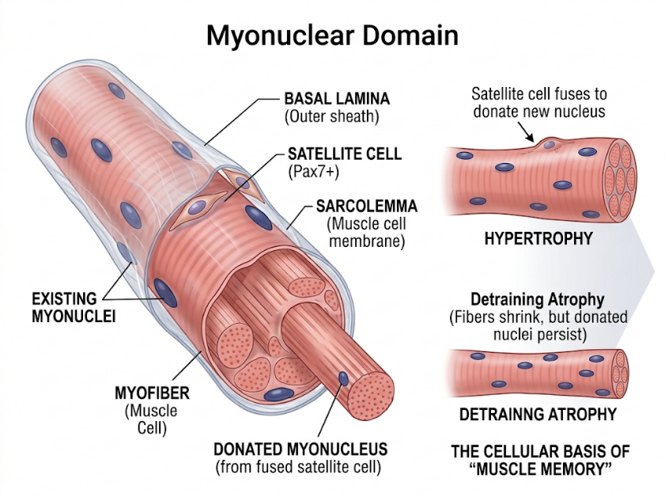
Cellular Fusion Machinery:
- The discovery of the transmembrane proteins Myomaker (Tmem8c) and Myomerger/Minion (Gm7325) resolved how skeletal myoblasts physically fuse into a multinucleated syncytium a mechanism absent in cardiac and smooth muscle.
T-Tubule / Sarcoplasmic Reticulum Organization:
- Skeletal Muscle Triads: Located specifically at the A–I band junctions (two triads per sarcomere in mammalian muscle).
- Cardiac Muscle Diads: Located at the Z-disc level (one per sarcomere, wider T-tubules with an external lamina).

Applied Anatomy
Malignant Hyperthermia:
- Mutations in the skeletal ryanodine receptor gene (RYR1) or CACNA1S (${\text{Ca}}_{V}1.1$) render RyR1 hyper-reactive to volatile anesthetics (halothane, isoflurane) and succinylcholine.
- Uncontrolled, sustained calcium release drives hypermetabolism, rigidity, and lethal hyperpyrexia.
- Dantrolene acts as a specific antidote by binding RyR1 and blocking calcium channel opening.
Catecholaminergic Polymorphic Ventricular Tachycardia:
- Mutations in cardiac RYR2 or cardiac calsequestrin (CASQ2) produce "leaky" channels during adrenergic stress.
- Spontaneous diastolic calcium sparks trigger delayed afterdepolarizations (DADs) via the electrogenic NCX1 (bringing in 3 ${\text{Na}}^{+}$ for every 1 ${\text{Ca}}^{2+}$ extruded), culminating in fatal ventricular arrhythmias.
Heart Failure and T-Tubule Remodelling:
- Pathologic cardiac remodelling involves downregulation or loss of Junctophilin-2 (JPH2). This widens the dyadic cleft and causes T-tubule disorganization, mechanically uncoupling ${\text{Ca}}_{V}1.2$ from RyR2.
- The resulting dyssynchronous CICR causes delayed, blunted force development and progressive systolic failure.
Cardiac Myocyte Turnover:
- Carbon-14 dating and lineage tracing demonstrate that adult human cardiomyocytes renew at a low rate ($≈0.5\text{-}1\%$ per year in early adulthood, decreasing with age), demonstrating that the myocardium is not completely post-mitotic.

Nervous system
Key points to remember:
- The central nervous system comprises the brain and spinal cord; the peripheral nervous system includes cranial nerves, spinal nerves, and peripheral ganglia.
- Afferent pathways convey sensory information towards the CNS; efferent pathways convey commands towards effectors.
- Neurons receive and transmit information, while glial cells support and maintain neural function.
- Oligodendrocytes form CNS myelin and Schwann cells form PNS myelin: myelination supports rapid conduction along axons.

General Consideration
Divisions
- Central nervous system
- Brain and spinal cord
- Peripheral nervous system
- Spinal nerves

Definition: Motor and sensory
- Sensory nerves = Afferent nerves
  - Nerves carrying impulses to central nervous system (brain and spinal cord)
- Motor nerves = Efferent nerves
  - Nerves carrying impulses to effector organs (muscles and glands)
- A mixed nerve carries both sensory and motor fibres. The median nerve, for example, supplies sensation to part of the hand and motor input to several forearm and hand muscles.

How a mixed spinal nerve form
The dorsal root carries sensory fibres into the spinal cord. The cell bodies of these sensory neurons lie in the dorsal root ganglion. The ventral root carries motor fibres out of the spinal cord. The two roots unite to form a short mixed spinal nerve. It then divides into dorsal and ventral rami, which both carry sensory and motor fibres.
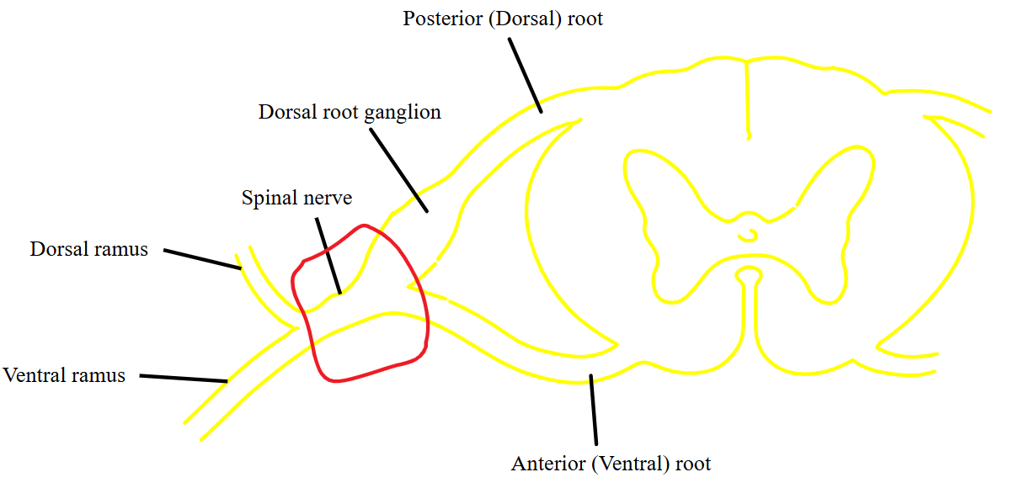

Parts of brain
Prosencephalon (Forebrain)
Divided into
Telencephalon - forms cerebrum
Diencephalon - forms thalamus, epithalamus, hypothalamus and deep seated cerebral nuclei

Mesencephalon - (Midbrain)

Rhombencephalon (Hindbrain)
Divided into
Metencephalon – forms pons and cerebellum
Myelencephalon - forms medulla
Cranial nerves
Direct connections with brain
12 pairs of cranial nerves
- Olfactory nerve
- Optic nerve
- Oculomotor nerve
- Trochlear nerve
- Trigeminal nerve
- Abducens nerve
- Facial nerve
- Vestibulocochlear nerve
- Glossopharyngeal nerve
- Vagus nerve
- Accessory nerve
- Hypoglossal nerve
Spinal cord
- Downward continuation of Medulla oblongata
- Extends from lower margin of foramen magnum
- Extends up to lower border of L1 vertebra in adults
- Extends up to L3 vertebra in infants
- Spinal cord is a component of the Central Nervous System while the spinal nerves are part of the Peripheral Nervous System

Spinal segment
Definition
- A segment of the spinal cord including a single pair of spinal nerves
- Represents spinal innervation of a single primitive metamere
- Each cord segment gives rise to a pair of spinal nerves
- Importance: In understanding the injuries to spinal cord - concept of spinal segment is essential
Spinal nerves
31 pairs of spinal nerves arise from cervical, thoracic, lumbar and sacral regions of the cord
- 8 cervical
- 12 thoracic
- 5 lumbar
- 5 sacral
- 1 coccygeal nerve
Neuron: An electrically excitable cell that processes and transmits information through electrical and chemical signals
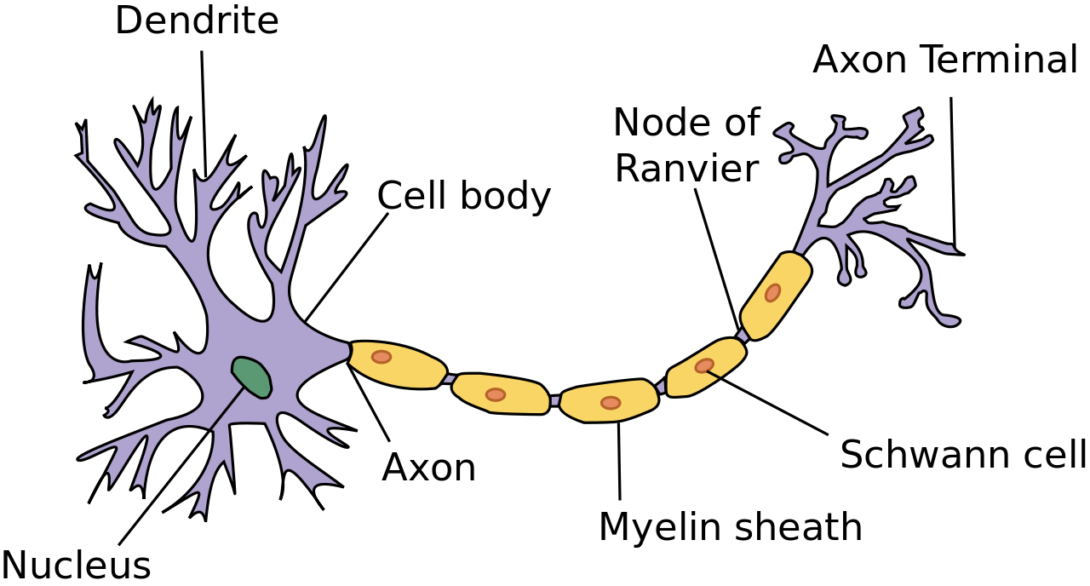
Classification based on dynamics
Golgi type I neuron is a neuron which has a long axon that begins in the grey matter of the central nervous system and may extend from there
Golgi II neurons, in contrast, are defined as having short axons or no axon at all
Classification based on shape
Pyramidal cells
Eg: Purkinje neurone from the cerebellum
Fusiform cells - Spindle shaped
Pyriform cells - Flask shaped
Classification based on polarity of processes extending from the cell body
1. Unipolar
2. Bipolar
3. Multipolar
4. Pseudo bipolar (wrongly named as pseudo unipolar)
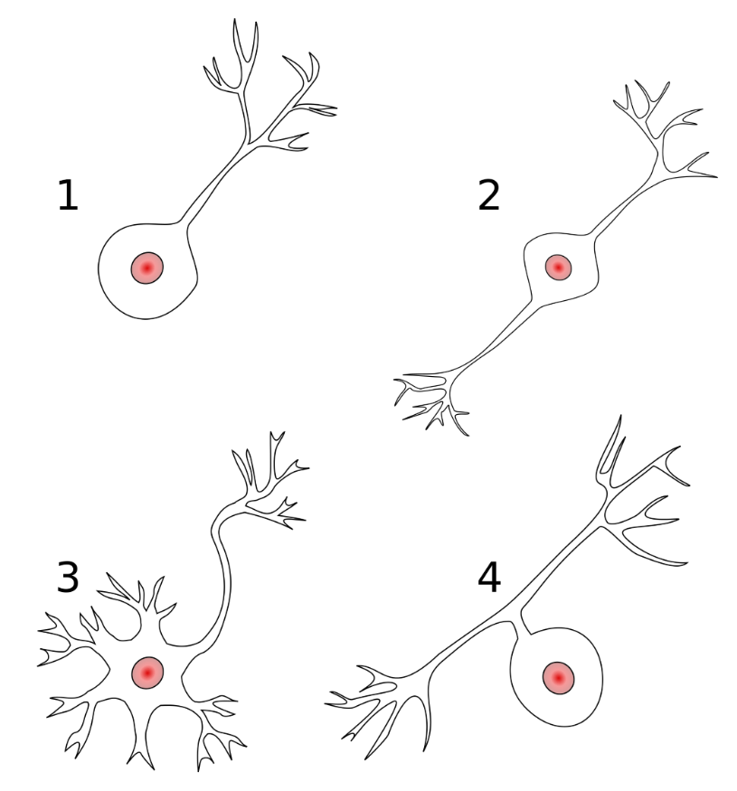
Peripheral nerve organisation
A peripheral nerve contains axons that carry signals between the central nervous system and peripheral structures such as the skin, muscles and glands.
Schwann cells support peripheral axons and form myelin around those that are myelinated.
Connective tissue supports the individual fibres, groups them into fascicles and binds the fascicles together.
Connective tissue coverings
Covering | What it surrounds | Main role
Endoneurium | Individual nerve fibres within a fascicle | Provides delicate support around the axon and its associated Schwann cell covering.
Perineurium | Each nerve fascicle | Forms a protective sleeve and helps regulate the movement of substances into the fascicle.
Epineurium | The whole nerve and the spaces between its fascicles | Binds the fascicles together, protects the nerve and carries larger vessels that supply it.

The word roots identify the level of organisation. Endo- means “within,” peri- means “around,” and epi- means “upon.”
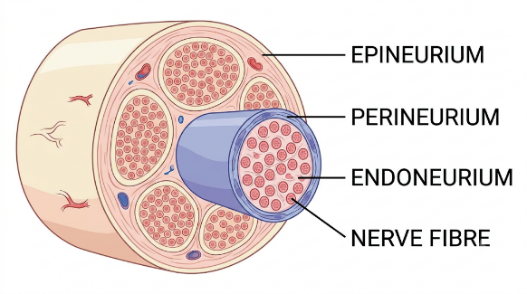
Ganglion
Definition: Collection of cell bodies outside CNS
Two broad categories of ganglia
1. Dorsal root ganglia
In relation to the spinal cord
2. Autonomic ganglia
Divided into
Sympathetic ganglia - just next to spinal cord
Parasympathetic ganglia - near the effector organs
 | Sympathetic ganglia | Spinal ganglia
Location | Next to vertebral column | Dorsal root of spinal nerve
Types of neurons | Multipolar neurons | Pseudo unipolar neurons
Arrangement | Scattered | Grouped

Neuroglia
Supporting cells of nervous system
Eg:
- Astrocytes - Forms blood brain barrier
- Oligodendrocytes - CNS myelination
- Microglia
- Ependymal cells

Schwann cells - for PNS myelination
Neuronal synapse
Places where neurons connect and communicate with each other
Components of synapse
Presynaptic terminal
- At the ends of the axon
- Places where electrical signal is converted to chemical signal
Postsynaptic terminal
- Has specialized receptors
Types of synapses
Electrical
- Connexins allow direct passage of current between the neurons
Chemical
- Neurotransmitters - convey the communication between the neurons
Types of chemical synapse
- Axodendritic - Connection between axon of a neuron with dendrite of the other
- Axosomatic - Connection between the axon of a neuron with cell body of the other
- Axoaxonic - Connection between the axon of a neuron with axon of the other
Denervation of a muscle
- Loss of innervation of a muscle
- Leads to muscular atrophy and degeneration (denervation atrophy)
- Muscle fails to act
Paralysis - complete loss of muscle function
Paresis - a condition of muscular weakness
Neural Plasticity (Neuroplasticity)
Neural plasticity refers to the capacity of the nervous system to modify its structural organization and functional properties in response to internal or external stimuli, learning, experience, developmental cues, or injury.
Fundamental Principle: Activity-dependent structural and functional synaptic remodeling (Hebbian plasticity).
Electrophysiological Basis: LTP (AMPA receptor insertion mediated by NMDA/$Ca^{2+}$/CaMKII) vs. LTD (AMPA receptor endocytosis via phosphatases).
Adult Neurogenesis Sites: Subgranular zone (hippocampus) and Subventricular zone (lateral ventricles).
CNS vs. PNS Regenerative Barrier: The CNS fails to regenerate long axons primarily due to myelin-associated inhibitors (Nogo-A, MAG) and the glial scar (CSPGs from reactive astrocytes), not because neurons inherently lack functional capacity.
Case based questions
An injured mixed nerve
A deep cut injures a peripheral nerve. The patient develops both reduced sensation in an area of skin and weakness of some muscles.
- Does this nerve belong to the central or peripheral nervous system?
- Which functional types of nerve fibres account for the sensory and motor changes?
- What does the combination of deficits indicate about the normal composition of this nerve?
Damage to myelin
A patient with a disorder confined to the central nervous system develops impaired conduction along several myelinated pathways.
- Which glial cell forms myelin in the central nervous system?
- Which cell performs this role in peripheral nerves?
- How does the arrangement of myelin and nodes of Ranvier support rapid conduction along an axon?

Lymphatic System
Key points to remember:
- Lymphatic vessels return excess interstitial fluid and escaped proteins to the bloodstream, helping maintain tissue fluid balance.
- Valves support one-way lymph flow, assisted by collecting-vessel contraction and surrounding muscle activity.
- Bone marrow and thymus are primary lymphoid organs; lymph nodes, spleen, and other lymphoid tissues support immune responses.
- Lymphatic obstruction can cause lymphoedema, while lymphatic pathways also provide routes for tumour spread.

Structure of lymph capillaries
Lymph capillaries are thin-walled vessels carrying lymph
They are lined by endothelial cells
Thin layer of smooth muscles (maintain tone) and collagen fibres surround these vessels
Located in all organs
- Lymph capillaries coalesce into larger lymphatic collectors
- while conventional initial lymphatics are absent from parenchymal brain tissue, drainage occurs via the glymphatic system (astrocyte AQP4 water channels) into newly described dural meningeal lymphatic vessels that exit along cranial nerves and dural sinuses to deep cervical nodes.
Lymph formation
- Protein extravasation from the microcirculation into the interstitial fluid
- Parenchymal organs may also contribute minimally to the protein component of the lymph
Lymph circulation
- Directional lymph flow - is controlled by unidirectional valves in lymph collectors
- Segment of lymph collectors between adjacent valves - called Lymphangion
- More distal lymphangion contracts in synchrony with valves - facilitate unidirectional flow
Lymph proteome changes with disease status
Components of lymphatic system
- Lymph - colorless, watery, bodily fluid carried by the lymphatic system, consisting mainly of white blood cells
- Lymphatic vessels - Lymph capillaries and lymph collectors
- Lymphatic organs
Components of lymphatic system
Primary lymphoid organs
- Thymus
- Bone marrow
Secondary lymphoid organs
- Simple
  - Diffuse lymphatic tissue (Mucosa associated lymphatic tissue MALT)
  - Solitary lymph nodes
  - Lymph node aggregates
- Intermediate
  - Tonsil
- Organs
  - Lymph nodes
  - Spleen

Functions
Primary lymphoid organs
- Lymphocyte education centers
- T cells - in the thymus
- B cells - in the bone marrow
Secondary lymphoid organs
- For removal of foreign bodies and dead cells
Clinical importance - lymphedema
Swelling in the part of the body due to accumulation of lymph
Commonly seen after removal of axillary lymph nodes and lymphatics as part of axillary dissection during breast cancer treatment
Clinical importance - spread of tumors
Cancers can spread via lymphatics (lymphatic metastasis)
Eg: Breast cancer
Case based questions
Arm swelling after surgery
Several months after breast surgery involving removal of axillary lymph nodes, a patient develops persistent swelling of the arm on the operated side.
- What is the term for swelling caused by impaired lymph drainage?
- What is the normal relationship between upper-limb lymphatic vessels and axillary lymph nodes?
- Why can interruption of this pathway produce tissue swelling even when arterial blood continues to enter the limb normally?
Examining the first draining node
During the assessment of a skin tumour, a tracer is used to identify the first lymph node or group of nodes receiving lymph from the tumour region.
- What is this first draining node called?
- Do afferent or efferent lymphatic vessels carry lymph into a node?
- Why can examination of this node provide information about possible lymphatic spread from the tumour?

Review questions
Instructions: Select the one best answer for each question.
1. A CT image shows a horizontal section through the abdomen, dividing the body into upper and lower parts. Which anatomical plane does this represent?
A. Coronal plane
B. Median plane
C. Transverse plane
D. Parasagittal plane
2. During examination, a patient moves the upper limb sideways, away from the trunk. What is this movement called?
A. Abduction
B. Adduction
C. Flexion
D. Medial rotation
3. A wound is described as being on the forearm, closer to the elbow than the wrist. Which term best describes its position relative to the wrist?
A. Superficial
B. Distal
C. Medial
D. Proximal
4. The alveoli of the lungs have a very thin lining that allows rapid gas exchange. Which epithelial type is best suited to this function?
A. Stratified squamous epithelium
B. Simple squamous epithelium
C. Simple cuboidal epithelium
D. Transitional epithelium
5. A tissue sample contains cells scattered within an abundant extracellular matrix containing fibres and ground substance. Which basic tissue does this description identify?
A. Connective tissue
B. Epithelial tissue
C. Muscle tissue
D. Nervous tissue
6. A tendon is adapted to resist strong pulling forces mainly along its length. Which arrangement best explains this property?
A. A network of branching elastic fibres
B. Closely packed epithelial cells
C. Parallel bundles of collagen fibres
D. Concentric layers of smooth muscle
7. A child sustains a fracture involving the epiphyseal plate. Which process is most directly threatened?
A. Formation of articular cartilage
B. Growth of the bone in length
C. Growth of the bone in thickness
D. Formation of the periosteal fibrous layer
8. During endochondral ossification, where does the primary ossification centre usually appear in a long bone?
A. Articular surface
B. Epiphysis
C. Epiphyseal plate
D. Diaphysis
9. Which statement correctly distinguishes the periosteum from the bone collar?
A. The periosteum is a connective tissue covering; the bone collar is bone formed around the cartilage model.
B. The periosteum is cartilage; the bone collar is fibrous connective tissue.
C. Both terms describe the same structure at different ages.
D. The periosteum lines the marrow cavity; the bone collar covers the articular surface.
10. A seven-year-old child develops a blood-borne infection that localises near the end of a long bone. Which region is the typical initial site of acute haematogenous osteomyelitis in this age group?
A. Articular cartilage
B. Epiphyseal plate
C. Metaphysis
D. Centre of the diaphysis
11. Which sequence correctly represents the differentiation of bone-forming cells?
A. Osteocyte → osteoblast → osteoprogenitor cell
B. Osteoblast → osteoclast → osteocyte
C. Osteoprogenitor cell → osteocyte → osteoblast
D. Osteoprogenitor cell → osteoblast → osteocyte
12. The patella develops within the tendon of the quadriceps femoris. How is it classified?
A. Pneumatic bone
B. Sesamoid bone
C. Flat bone
D. Irregular bone
13. A small defect in adult articular cartilage heals poorly. Which anatomical feature chiefly contributes to its limited repair?
A. An abundant supply of lymphatic vessels
B. A thick periosteal covering
C. Absence of blood vessels within the cartilage
D. Numerous blood vessels in its matrix
14. Which type of cartilage is characteristic of an intervertebral disc’s annulus fibrosus?
A. Fibrocartilage
B. Elastic cartilage
C. Hyaline cartilage
D. Calcified articular cartilage
15. Following a leg injury, swelling develops within a muscle compartment and compresses its blood vessels and nerves. Which property of deep fascia contributes to this problem?
A. Its rich supply of sweat glands
B. Its ability to secrete synovial fluid
C. Its loose attachment to the epidermis
D. Its limited capacity to stretch
16. At the wrist, a thickened band of deep fascia holds tendons close to the underlying bones and prevents bowstringing. What is this structure called?
A. Bursa
B. Retinaculum
C. Raphe
D. Interosseous membrane
17. A superficial abrasion removes only the epidermis. Why may it produce no bleeding?
A. The epidermis contains no blood vessels.
B. The epidermis contains no nerve endings.
C. Blood vessels occur only in subcutaneous tissue.
D. Epidermal blood vessels close permanently after birth.
18. A surgeon plans an incision parallel to the skin’s natural tension lines. What is the principal anatomical advantage?
A. Complete avoidance of cutaneous nerves
B. Prevention of all wound infection
C. Reduced separation of the wound edges
D. Elimination of the need for sutures
19. Which feature most reliably identifies a synovial joint?
A. Direct union of bones by cartilage
B. Complete absence of movement
C. Direct union of bones by dense fibrous tissue
D. A joint cavity enclosed by a capsule
20. The first carpometacarpal joint allows the thumb to move in two principal planes and contributes to opposition. What type of synovial joint is it?
A. Pivot joint
B. Saddle joint
C. Hinge joint
D. Plane joint
21. The pubic symphysis is an example of which type of joint?
A. Secondary cartilaginous joint
B. Primary cartilaginous joint
C. Fibrous suture
D. Synovial plane joint
22. An artery becomes blocked gradually, but the tissue continues to receive blood through connections with neighbouring arteries. What are these connections called?
A. Venous valves
B. Lymphatic channels
C. Arterial anastomoses
D. Capillary sphincters
23. A person stands still for a prolonged period. Which structures within many lower-limb veins help prevent blood from flowing backwards?
A. Thick elastic lamellae
B. Cartilaginous rings
C. Arteriovenous shunts
D. Valves
24. A thrombus completely blocks an anatomical end artery that has no effective alternative arterial supply. What is the most likely consequence for the tissue it supplies?
A. Increased lymphatic drainage
B. Ischaemia with a risk of infarction
C. Increased arterial perfusion
D. Immediate development of a second artery
25. Two muscles have a similar overall size. One has fibres running approximately parallel to its long axis; the other has fibres arranged obliquely around a tendon. Which statement best describes the pennate arrangement?
A. It generally accommodates more fibres and favours greater force production.
B. It always produces a greater range of shortening.
C. Its fibres insert directly into bone without a tendon.
D. It contains only smooth muscle fibres.
26. During elbow flexion, the brachialis acts as a prime mover. Which muscle acts as an antagonist to this movement?
A. Biceps brachii
B. Brachioradialis
C. Triceps brachii
D. Pronator teres
27. A histological section of a peripheral nerve shows several fascicles. Which connective tissue sheath surrounds each individual fascicle?
A. Epimysium
B. Perineurium
C. Endoneurium
D. Epineurium
28. An injury to a peripheral nerve causes both loss of skin sensation and weakness of skeletal muscles. How is this nerve best classified?
A. Pure sensory nerve
B. Pure motor nerve
C. Pure autonomic nerve
D. Mixed nerve
29. A patient develops persistent swelling of the upper limb after removal of axillary lymph nodes. What is the principal anatomical explanation?
A. Impaired lymphatic drainage from the limb
B. Loss of arterial valves
C. Increased formation of articular cartilage
D. Obstruction of the limb’s motor nerves
30. Which structural feature allows interstitial fluid to enter initial lymphatic capillaries?
A. A thick layer of circular smooth muscle
B. A continuous layer of keratinised cells
C. Overlapping endothelial cells that act as flap-like valves
D. Open communication with nearby arteries

Answers and explanations
No. | Answer | Explanation
1 | C — Transverse plane | A transverse plane divides the body into superior and inferior parts.
2 | A — Abduction | Abduction moves a body part away from the median plane.
3 | D — Proximal | Proximal means nearer the attachment or root of a limb.
4 | B — Simple squamous epithelium | A single layer of flattened cells provides a thin surface for diffusion.
5 | A — Connective tissue | An abundant extracellular matrix is a characteristic feature of connective tissue.
6 | C — Parallel bundles of collagen fibres | Tendons contain dense regular connective tissue adapted to tensile forces along the fibre direction.
7 | B — Growth of the bone in length | Longitudinal growth depends on cartilage growth and its replacement by bone at the epiphyseal plate.
8 | D — Diaphysis | The primary ossification centre usually develops in the shaft; secondary centres usually develop in the epiphyses.
9 | A — Connective tissue covering versus bone | The periosteum is a covering with an inner osteogenic layer. The bone collar is bone deposited around the shaft of the cartilage model.
10 | C — Metaphysis | The arrangement of metaphyseal vessels, including slow flow in terminal vascular loops, favours localisation of blood-borne bacteria in children.
11 | D — Osteoprogenitor cell → osteoblast → osteocyte | Osteoblasts form bone matrix. Those enclosed within the matrix differentiate into osteocytes.
12 | B — Sesamoid bone | Sesamoid bones develop within tendons. The patella also improves the mechanical advantage of the quadriceps.
13 | C — Absence of blood vessels | Articular cartilage is avascular and lacks perichondrium, limiting its capacity for repair.
14 | A — Fibrocartilage | Fibrocartilage in the annulus fibrosus helps resist tensile and compressive stresses.
15 | D — Limited capacity to stretch | Firm fascial boundaries restrict expansion. Rising pressure can compromise tissue perfusion and nerve function.
16 | B — Retinaculum | A retinaculum is a local thickening of deep fascia that holds tendons close to underlying structures.
17 | A — The epidermis contains no blood vessels | The epidermis receives nutrients by diffusion from vessels in the underlying dermis.
18 | C — Reduced separation of wound edges | Incisions parallel to skin tension lines generally gape less and may produce less conspicuous scars.
19 | D — A joint cavity enclosed by a capsule | A synovial cavity is the defining feature. The articulating surfaces are covered by articular cartilage.
20 | B — Saddle joint | Its reciprocally concave and convex surfaces allow movement in two principal planes.
21 | A — Secondary cartilaginous joint | A symphysis joins bones through fibrocartilage, with hyaline cartilage covering the opposing bony surfaces.
22 | C — Arterial anastomoses | Connections between arteries can provide alternative routes for blood flow.
23 | D — Valves | Venous valves limit backward flow; skeletal muscle contractions help propel blood towards the heart.
24 | B — Ischaemia with a risk of infarction | Without an effective alternative supply, arterial obstruction deprives tissue of oxygen and may cause tissue death.
25 | A — More fibres and greater force production | Pennation permits a larger physiological cross-sectional area within a given muscle volume, favouring force production.
26 | C — Triceps brachii | Triceps extends the elbow and therefore opposes elbow flexion.
27 | B — Perineurium | Perineurium surrounds a fascicle; endoneurium surrounds individual nerve fibres, and epineurium surrounds the whole nerve.
28 | D — Mixed nerve | A mixed nerve contains both sensory and motor fibres.
29 | A — Impaired lymphatic drainage | Disruption of lymphatic pathways allows interstitial fluid and proteins to accumulate, producing lymphoedema.
30 | C — Overlapping endothelial cells | Their overlapping edges permit fluid entry when interstitial pressure exceeds pressure within the lymphatic capillary.

Glossary
Simple meanings of the main terms used in this book. Terms are grouped by topic for easy revision.
1. General terms, position and direction
Term | Simple meaning
Anatomy | Study of the structure of the body.
Physiology | Study of how the body works.
Gross anatomy | Study of body structures visible without a microscope.
Histology | Study of tissues using a microscope.
Embryology | Study of development before birth.
Dissection | Carefully separating tissues to study their structure.
Cell | The smallest living unit of the body.
Tissue | A group of cells and surrounding material working together.
Organ | A body part made of different tissues working together.
Organ system | A group of organs performing related functions.
Anatomical position | Standing upright, facing forward, arms at the sides and palms facing forward.
Supine | Lying face up.
Prone | Lying face down.
Anterior | Towards the front of the body.
Posterior | Towards the back of the body.
Superior | Towards the head or above another structure.
Inferior | Towards the feet or below another structure.
Medial | Nearer the body’s midline.
Lateral | Farther from the body’s midline.
Median | Exactly in the midline.
Proximal | Nearer the attachment or beginning of a structure.
Distal | Farther from the attachment or beginning of a structure.
Superficial | Nearer the body surface.
Deep | Farther from the body surface.
Internal | Inside a structure.
External | Outside a structure.
Ipsilateral | On the same side of the body.
Contralateral | On opposite sides of the body.
Bilateral | Present on both sides.
Unilateral | Present on one side only.
Palmar | Relating to the palm of the hand.
Plantar | Relating to the sole of the foot.
Dorsum | The back of the hand or the upper surface of the foot.

2. Planes and movements
Term | Simple meaning
Plane | An imaginary flat surface passing through the body.
Section | A view obtained by cutting or imaging through a structure.
Median plane | A vertical plane dividing the body into equal right and left halves.
Sagittal plane | A vertical plane dividing the body into right and left parts.
Parasagittal plane | A sagittal plane lying beside the median plane.
Coronal or frontal plane | A vertical plane dividing the body into front and back parts.
Transverse or axial plane | A plane dividing the body into upper and lower parts.
Oblique plane | A plane passing through the body at a slant.
Longitudinal section | A section along the length of a structure.
Cross-section | A section across the length of a structure.
Axis of movement | An imaginary line around which movement occurs.
Flexion | Bending a joint, usually decreasing the angle between body parts.
Extension | Straightening a joint, usually increasing the angle between body parts.
Abduction | Movement away from the midline; fingers and toes use their own reference lines.
Adduction | Movement towards the midline; fingers and toes use their own reference lines.
Rotation | Turning a body part around its long axis.
Medial rotation | Turning the front of a limb towards the body’s midline.
Lateral rotation | Turning the front of a limb away from the body’s midline.
Circumduction | A circular movement in which the moving part traces a cone.
Pronation | Rotating the forearm so the palm faces backwards or downwards.
Supination | Rotating the forearm so the palm faces forwards or upwards.
Dorsiflexion | Moving the top of the foot towards the shin.
Plantarflexion | Pointing the foot and toes downwards.
Inversion | Turning the sole of the foot inwards.
Eversion | Turning the sole of the foot outwards.
Opposition | Moving the thumb across the palm to touch a fingertip.
Reposition | Returning the thumb from opposition to its resting position.
Elevation | Moving a body part upwards.
Depression | Moving a body part downwards.
Protraction | Moving a body part forwards, such as the jaw.
Retraction | Moving a body part backwards.

3. Basic tissues
Term | Simple meaning
Epithelium | Tissue that covers surfaces, lines spaces and forms many glands.
Simple epithelium | Epithelium with one layer of cells.
Stratified epithelium | Epithelium with two or more layers of cells.
Squamous | Having flat, thin cells.
Cuboidal | Having cells that are roughly cube-shaped.
Columnar | Having cells that are taller than they are wide.
Pseudostratified epithelium | One cell layer that looks like several layers.
Transitional epithelium | A specialised lining that stretches, as in the urinary bladder.
Apical surface | The cell surface facing an open space or the outside.
Basal surface | The bottom surface of an epithelial cell, facing its supporting layer.
Basement membrane | A thin supporting layer beneath epithelium.
Lumen | The space inside a tube or hollow organ.
Gland | A cell or group of cells that makes and releases a substance.
Secretion | The release of a substance made by a cell or gland.
Connective tissue | Tissue that supports, binds, protects or connects body structures.
Extracellular matrix | Material outside cells that surrounds and supports them.
Ground substance | The gel-like material between cells and fibres.
Fibroblast | A cell that makes fibres and other material in connective tissue.
Collagen | A strong protein that helps tissues resist pulling forces.
Elastic fibres | Fibres that allow tissues to stretch and return to shape.
Loose connective tissue | Connective tissue with loosely arranged fibres and plenty of space between them.
Dense connective tissue | Connective tissue containing many closely packed fibres.
Adipose tissue | Fat-storing tissue that also cushions and insulates the body.
Mesenchyme | Early developing tissue that gives rise to many supporting tissues.
Vascular | Containing blood vessels.
Avascular | Having no blood vessels.
Diffusion | Movement of particles from a region of higher to lower concentration.
Regeneration | Replacement of damaged cells with the same type of cells.
Fibrosis | Formation of excess fibrous tissue, often after injury.
Scar | Fibrous tissue that replaces damaged tissue during healing.

4. Bones and bone growth
Term | Simple meaning
Skeleton | The framework of bones and cartilage supporting the body.
Axial skeleton | Bones of the skull, vertebral column and chest.
Appendicular skeleton | Bones of the limbs and the girdles attaching them to the trunk.
Long bone | A bone longer than it is wide, with a shaft and two ends.
Short bone | A bone with roughly similar length, width and thickness.
Flat bone | A thin, flattened bone, such as the scapula.
Irregular bone | A bone with a complex shape, such as a vertebra.
Pneumatic bone | A bone containing an air-filled space.
Sesamoid bone | A bone that develops within a tendon, such as the patella.
Accessory bone | An extra bone separate from the usual bones of the skeleton.
Compact or cortical bone | Dense bone forming the strong outer layer of a bone.
Cancellous or spongy bone | Bone formed of a network of thin plates and bars with spaces between them.
Trabecula | A small plate or bar forming the framework of spongy bone.
Diaphysis | The shaft of a long bone.
Epiphysis | A part of a growing bone that develops from a secondary ossification centre.
Metaphysis | The region of a long bone between the shaft and the growth plate.
Epiphyseal or growth plate | Cartilage where a growing bone increases in length.
Epiphyseal line | The bony mark left after a growth plate closes.
Pressure epiphysis | An epiphysis that forms part of a joint and transmits force.
Traction epiphysis | An epiphysis at a muscle attachment that receives pulling force.
Atavistic epiphysis | An epiphysis corresponding to a separate bone in ancestral animals.
Aberrant epiphysis | An occasional epiphysis at a site where one is not usually present.
Periosteum | The connective tissue covering the outside of bone, except its joint surfaces.
Endosteum | The thin tissue lining internal bone surfaces.
Medullary cavity | The marrow-containing space inside the shaft of a long bone.
Bone marrow | Soft tissue within bones; red marrow produces blood cells.
Nutrient artery | A major artery entering a bone to supply its internal tissues.
Nutrient foramen | The opening through which a nutrient vessel enters a bone.
Ossification | Formation of bone.
Ossification centre | A site where bone formation begins.
Primary ossification centre | The first main site of bone formation, usually in the shaft.
Secondary ossification centre | A later site of bone formation, usually in an epiphysis.
Endochondral ossification | Bone formation by replacing an existing cartilage model.
Intramembranous ossification | Bone formation directly within connective tissue, without a cartilage model.
Bone collar | A thin sleeve of new bone around the shaft of a developing cartilage model.
Periosteal bud | Blood vessels and accompanying cells entering a developing bone.
Osteoprogenitor cell | A cell that can develop into an osteoblast.
Osteoblast | A cell that forms new bone matrix.
Osteocyte | A mature bone cell enclosed within bone matrix.
Osteoclast | A cell that breaks down and removes bone.
Osteoid | Newly formed bone matrix before minerals are deposited in it.
Calcification | Deposition of calcium salts in a tissue.
Mineralisation | Deposition of minerals that make a tissue harder.
Hypertrophy | Increase in the size of cells.
Proliferation | Increase in cell number through cell division.
Resorption | Breakdown and removal of tissue.
Bone remodelling | Renewal and reshaping of bone by removal and replacement.
Appositional growth | Growth by adding new tissue to a surface.
Interstitial growth | Growth from within a tissue.
Lamella | A thin layer of bone matrix.
Osteon | A cylindrical unit of compact bone arranged around a central canal.
Haversian canal | The central canal of an osteon, containing vessels and nerves.
Volkmann’s canal | A channel connecting blood vessels across compact bone.
Lacuna | A small space containing a cell in bone or cartilage.
Canaliculi | Tiny channels connecting bone cells with each other and nearby blood supply.
Enthesis | The site where a tendon or ligament attaches to bone.

5. Cartilage
Term | Simple meaning
Cartilage | Firm, flexible supporting tissue with cells in a gel-like matrix.
Chondroblast | A cell that produces cartilage matrix.
Chondrocyte | A mature cartilage cell lying in a lacuna.
Perichondrium | The connective tissue covering most cartilage.
Hyaline cartilage | Smooth, glassy-looking cartilage found at joints and in growth plates.
Elastic cartilage | Flexible cartilage containing elastic fibres, as in the external ear.
Fibrocartilage | Tough cartilage containing thick collagen bundles, as in intervertebral discs.
Articular cartilage | Smooth cartilage covering the bone surfaces of a synovial joint.
Calcified cartilage | Cartilage with mineral deposits in its matrix; it is not the same as bone.
Reserve zone | The growth-plate region containing relatively inactive cartilage cells.
Proliferative zone | The growth-plate region where cartilage cells divide and form columns.
Hypertrophic zone | The growth-plate region where cartilage cells enlarge.
Zone of calcification | The region where the cartilage matrix becomes mineralised.
Zone of ossification | The region where new bone is deposited on remaining calcified cartilage.
Primary spongiosa | Newly formed trabeculae containing calcified cartilage covered by bone.
Secondary spongiosa | More mature spongy bone formed by remodelling early trabeculae.

6. Fascia and skin
Term | Simple meaning
Fascia | Sheets of connective tissue that surround, support and connect structures.
Superficial fascia | Loose connective tissue beneath the skin, often containing fat.
Deep fascia | Tough connective tissue surrounding muscles and other deeper structures.
Intermuscular septum | A connective tissue partition separating groups of muscles.
Muscle compartment | A group of muscles, vessels and nerves enclosed by fascia and bone.
Retinaculum | A thickened fascial band holding tendons close to underlying structures.
Aponeurosis | A broad, flat tendon.
Raphe | A line where tissues from opposite sides join.
Interosseous membrane | A fibrous sheet connecting two bones.
Epidermis | The outer, avascular layer of the skin.
Dermis | The supporting skin layer containing vessels, nerves and glands.
Hypodermis | The tissue beneath the skin, often rich in fat.
Keratin | A tough protein found in the epidermis, hair and nails.
Melanin | The pigment that contributes to skin colour and protection from sunlight.
Hair follicle | The skin structure from which a hair grows.
Sebaceous gland | A gland that releases oily sebum into a hair follicle or onto skin.
Sweat gland | A gland that produces sweat.
Arrector pili | A tiny smooth muscle that raises a hair, producing goosebumps.
Dermatome | An area of skin supplied mainly by one spinal nerve root.
Dermatoglyphics | The study of skin ridge patterns on fingers, palms, toes and soles.
Friction ridges | Raised skin lines that form fingerprints and improve grip.
Skin tension lines | Lines showing the main direction of tension within the skin.
Incision | A cut made during a surgical procedure.

7. Joints
Term | Simple meaning
Joint or articulation | A place where two or more bones meet.
Fibrous joint | A joint where bones are joined by fibrous connective tissue.
Suture | A fibrous joint between skull bones.
Syndesmosis | A fibrous joint joined by a ligament or an interosseous membrane.
Gomphosis | The joint between a tooth and its socket.
Cartilaginous joint | A joint where bones are joined by cartilage.
Synchondrosis | A primary cartilaginous joint joined by hyaline cartilage.
Symphysis | A secondary cartilaginous joint with fibrocartilage between the bones.
Synovial joint | A joint with a fluid-containing cavity between its articulating surfaces.
Joint cavity | The space between the surfaces of a synovial joint.
Joint capsule | The tissue sleeve enclosing a synovial joint.
Fibrous capsule | The tough outer layer of a synovial joint capsule.
Synovial membrane | The inner lining that helps produce synovial fluid.
Synovial fluid | Fluid that lubricates a joint and nourishes its articular cartilage.
Ligament | A strong connective tissue band usually joining one bone to another.
Articular disc | A plate of fibrocartilage between joint surfaces.
Meniscus | A crescent-shaped pad of fibrocartilage within a joint.
Labrum | A fibrocartilage rim that deepens a joint socket.
Bursa | A small fluid-containing sac that reduces friction between moving structures.
Tendon sheath | A sleeve containing lubricating fluid around a tendon.
Plane joint | A synovial joint allowing mainly gliding movements.
Hinge joint | A synovial joint allowing mainly bending and straightening.
Pivot joint | A synovial joint allowing rotation around one axis.
Condyloid joint | A synovial joint with an oval surface fitting into an oval hollow.
Saddle joint | A joint whose surfaces are each curved inwards in one direction and outwards in another.
Ball-and-socket joint | A joint with a rounded head fitting into a socket, allowing movement in many directions.
Uniaxial | Allowing movement around one axis.
Biaxial | Allowing movement around two axes.
Multiaxial | Allowing movement around several axes.

8. Blood vessels and circulation
Term | Simple meaning
Artery | A blood vessel carrying blood away from the heart.
Vein | A blood vessel carrying blood towards the heart.
Arteriole | A small artery that controls blood flow into capillaries.
Capillary | A tiny vessel where substances pass between blood and tissues.
Venule | A small vessel collecting blood from capillaries.
Endothelium | The thin cell lining inside blood and lymphatic vessels.
Tunica intima | The innermost layer of a blood vessel wall.
Tunica media | The middle vessel layer, containing mainly smooth muscle and elastic tissue.
Tunica adventitia | The outer supporting connective tissue layer of a blood vessel.
Vasa vasorum | Small vessels supplying the walls of large blood vessels.
Venous valve | A flap inside a vein that helps prevent backward blood flow.
Anastomosis | A connection between vessels or other tubular structures.
Collateral circulation | Blood flow through an alternative route around a blockage.
Anatomical end artery | An artery with no connections providing an alternative arterial supply.
Functional end artery | An artery whose connections cannot provide enough blood if it is blocked.
Arteriovenous anastomosis | A direct connection between an artery and a vein, bypassing capillaries.
Portal system | A circulation in which blood passes through two capillary beds before returning to the heart.
Perfusion | Delivery of blood through a tissue.
Ischaemia | Inadequate blood supply to a tissue.
Infarction | Death of tissue caused by loss of its blood supply.
Thrombus | A blood clot formed inside a vessel or the heart.
Thrombosis | Formation of a thrombus.
Embolus | Material carried in blood that can lodge in and block a vessel.
Embolism | Blockage of a vessel by travelling material, such as a blood clot.
Haemorrhage | Bleeding from a damaged blood vessel.
Haematoma | A collection of blood outside blood vessels.

9. Muscles
Term | Simple meaning
Muscle fibre | A muscle cell.
Fascicle | A bundle of muscle fibres; in a nerve, a bundle of nerve fibres.
Skeletal muscle | Striated muscle that usually moves bones and is mainly under voluntary control.
Cardiac muscle | The muscle of the heart wall that pumps blood.
Smooth muscle | Non-striated muscle in structures such as the intestine and blood vessels.
Striated | Showing alternating light and dark bands under a microscope.
Voluntary | Usually under conscious control.
Involuntary | Working without conscious control.
Muscle belly | The fleshy, contractile part of a muscle.
Tendon | A strong cord or band connecting a muscle to its attachment.
Origin | The attachment that usually moves less during a muscle’s action.
Insertion | The attachment that usually moves more during a muscle’s action.
Muscle architecture | The arrangement of muscle fibres in relation to their tendons.
Parallel muscle | A muscle whose fibres run mainly along its length.
Fusiform muscle | A spindle-shaped muscle with a thick middle and narrow ends.
Pennate muscle | A muscle whose fibres attach obliquely to a tendon, like a feather.
Unipennate | Having fibres attached to one side of a tendon.
Bipennate | Having fibres attached to both sides of a tendon.
Multipennate | Having several feather-like groups of fibres.
Agonist or prime mover | A muscle mainly responsible for a particular movement.
Antagonist | A muscle whose action opposes a particular movement.
Synergist | A muscle that helps another muscle perform a movement.
Fixator | A muscle that holds a body part steady while another part moves.
Muscle tone | The slight, ongoing activity that helps muscles maintain posture.
Endomysium | Connective tissue around an individual muscle fibre.
Perimysium | Connective tissue around a muscle fascicle.
Epimysium | Connective tissue around a whole skeletal muscle.
Motor unit | One motor neuron and all the muscle fibres it supplies.
Neuromuscular junction | The site where a motor neuron communicates with a skeletal muscle fibre.

10. Nervous system
Term | Simple meaning
Central nervous system — CNS | The brain and spinal cord.
Peripheral nervous system — PNS | Nerves and ganglia outside the brain and spinal cord.
Neuron | A nerve cell that receives and sends signals.
Cell body | The part of a neuron containing its nucleus.
Dendrite | A branch that usually carries signals towards a neuron’s cell body.
Axon | A process that usually carries signals away from a neuron’s cell body.
Nerve fibre | An axon together with its surrounding coverings.
Nerve | A bundle of nerve fibres outside the brain and spinal cord.
Tract | A bundle of axons within the brain or spinal cord.
Ganglion | A collection of neuron cell bodies outside the brain and spinal cord.
Nucleus, in neuroanatomy | A group of neuron cell bodies within the brain or spinal cord.
Sensory or afferent fibre | A fibre carrying information towards the central nervous system.
Motor or efferent fibre | A fibre carrying commands from the central nervous system to an effector.
Mixed nerve | A nerve containing both sensory and motor fibres.
Receptor | A specialised cell or nerve ending that detects a change.
Effector | A muscle or gland that carries out a response.
Somatic nervous system | The system concerned with body sensation and control of skeletal muscles.
Autonomic nervous system | The system regulating internal organs, glands, smooth muscle and cardiac muscle.
Sympathetic division | The autonomic division that prepares the body for activity and stress.
Parasympathetic division | The autonomic division that supports functions such as digestion and recovery.
Synapse | A junction where a neuron communicates with another cell.
Neurotransmitter | A chemical messenger released by a neuron.
Reflex | An automatic response to a stimulus.
Reflex arc | The nerve pathway producing a reflex response.
Glial cells or neuroglia | Cells that support, protect and maintain neurons.
Myelin | An insulating covering around some axons that speeds signal transmission.
Schwann cell | A supporting cell that forms myelin around peripheral axons.
Oligodendrocyte | A cell that forms myelin in the brain and spinal cord.
Astrocyte | A glial cell that supports neurons and helps control their surroundings.
Microglia | Immune cells that remove damaged material in the brain and spinal cord.
Node of Ranvier | A small gap between neighbouring myelin segments along an axon.
Endoneurium | Delicate connective tissue around an individual peripheral nerve fibre.
Perineurium | The protective sheath around a nerve fascicle.
Epineurium | The outer connective tissue around a whole peripheral nerve.
Dorsal root | The sensory root of a spinal nerve.
Ventral root | The motor root of a spinal nerve.
Dorsal root ganglion | A collection of sensory neuron cell bodies on a dorsal root.
Ramus | A branch of a nerve or another structure.
Nerve plexus | A network formed by joining and dividing nerve branches.
Grey matter | Nervous tissue rich in neuron cell bodies, dendrites and synapses.
White matter | Nervous tissue containing mainly axons, many covered by myelin.
Cerebrum | The largest brain region, involved in thought, sensation and voluntary movement.
Cerebellum | The brain region that helps coordinate movement and balance.
Brainstem | The midbrain, pons and medulla, connecting higher brain regions with the spinal cord.
Thalamus | A brain region that relays much sensory information to the cerebral cortex.
Hypothalamus | A brain region regulating functions such as temperature, hunger and hormone control.
Meninges | The three protective coverings of the brain and spinal cord.
Cerebrospinal fluid — CSF | Fluid surrounding and cushioning the brain and spinal cord.
Neuroplasticity | The nervous system’s ability to change its connections and activity.

11. Lymphatic system
Term | Simple meaning
Interstitial fluid | Fluid in the spaces between tissue cells.
Lymph | Fluid that has entered lymphatic vessels from the tissues.
Lymphatic capillary | A tiny, blind-ended vessel that collects fluid from tissues.
Lymphatic vessel | A vessel carrying lymph towards the venous circulation.
Lymph node | A small organ that filters lymph and helps organise immune responses.
Afferent lymphatic vessel | A vessel carrying lymph into a lymph node.
Efferent lymphatic vessel | A vessel carrying lymph out of a lymph node.
Lymphatic drainage | Removal of tissue fluid through lymphatic vessels.
Thoracic duct | The main lymphatic duct, draining most of the body into veins on the left.
Right lymphatic duct | A duct draining the right upper part of the body into veins on the right.
Lacteal | A lymphatic capillary in the small intestine that absorbs dietary fats.
Lymphoid tissue | Tissue rich in immune cells that help defend the body.
Lymphocyte | A white blood cell involved in immune defence.
Oedema | Swelling caused by excess fluid between tissue cells.
Lymphoedema | Swelling caused by impaired lymphatic drainage.
Sentinel lymph node | One of the first lymph nodes receiving drainage from a particular area or tumour.

12. Clinical terms
Term | Simple meaning
Fracture | A break in a bone.
Callus | Repair tissue that forms around and between the ends of a healing fracture.
Growth-plate injury | Damage to the cartilage responsible for a growing bone’s increase in length.
Osteomyelitis | Infection involving bone and usually its marrow.
Avascular necrosis | Death of bone tissue because its blood supply is lost.
Osteoporosis | Reduced bone strength that increases the risk of fracture.
Sprain | An injury that stretches or tears a ligament.
Strain | An injury that stretches or tears a muscle or tendon.
Dislocation | Complete loss of normal contact between joint surfaces.
Subluxation | Partial loss of normal contact between joint surfaces.
Arthritis | Inflammation of a joint.
Osteoarthritis | A joint disease involving cartilage damage and changes in surrounding tissues.
Compartment syndrome | Harmful pressure within a closed tissue compartment that reduces blood supply.
Atrophy | A decrease in the size of cells, a tissue or an organ.
Paralysis | Loss of the ability to move a muscle or body part.
Paresis | Partial loss of muscle strength.
Paraesthesia | An unusual sensation, such as tingling or pins and needles.
Inflammation | The body’s response to injury or infection, often causing pain, warmth and swelling.
Necrosis | Death of cells or tissue within the living body.
Metastasis | Spread of cancer from its original site to another part of the body.
Stem cell | A cell that can renew itself and produce specialised cells.
Differentiation | The process by which a cell becomes specialised.
Cell reprogramming | Changing a cell’s identity or developmental state.
Tissue plasticity | The ability of cells or tissues to change their properties.
Immunohistochemistry — IHC | Using antibodies to identify particular proteins in tissue sections.
Cell marker | A feature, often a protein, used to help identify a cell type.
Epithelial–mesenchymal transition — EMT | A change in which epithelial cells acquire more mobile, less tightly attached features.
Artificial cornea | A manufactured optical device used to replace the eye’s clear front window.
Osteo-odonto-keratoprosthesis — OOKP | An artificial cornea supported by a piece of the patient’s tooth and surrounding bone.
Rehabilitation | Training and treatment to improve function after illness or injury.

